## Add Swagger in the Rest API

- **Add Dependancy:**

<!-- Open API Documentation START -->

<dependency>

<groupId>org.springdoc</groupId>

<artifactId>springdoc-openapi-starter-webmvc-ui</artifactId>

<version>2.2.0</version>

</dependency>

<!-- Open API Documentation END →

## - Add the Annotation in the Main File for the Documentation @OpenAPIDefinition(

info = @Info(title = "Accounts Microservice REST API Documentation",

description = "Bank Account MicroSErvices REST API", version = "v1",

contact = @Contact(

name = "Pritesh Desai",

email = "[priteshdesai1811@gmail.com](mailto:priteshdesai1811@gmail.com)", url="[www.google.com](http://www.google.com/)"),

license = @License(name = "Apache 2.0", url = "[www.google.com](http://www.google.com/)")

Document",

),

externalDocs = @ExternalDocumentation( description = "Bank Account Microservice

url = "[www.google.com](http://www.google.com/)"

)

)

## Add class level annotation for the controller

@Tag(name = "Account CRUD APIS Details", description = "This API contains the CRUD API for the Account")

## Add the Method level annotation for the API Methods

@Operation(summary = "This API use for update the Customer", description = "This API use for update the Customer with the PUT Method")

@ApiResponses({ @ApiResponse(responseCode = "200", description = "Http Status

OK"),

Server Erorr") })

@ApiResponse(responseCode = "500", description = "Http Internal

## Add class level annotation for the DTO.

@Schema(name = "Account", description = "Holds the information for the Customer Account")

## Add property level annotation in the DTO class

@Schema(description = "Account Number of the Customer") @NotEmpty(message = "accountNumber can not be Null or Empty")

@Pattern(regexp = "^$|[0-9]{10}", message = "accountNumber Must be 10 Digits")

private Long accountNumber;

## Create the Microservice in the Docker Image

Press **Ctrl+C** for terminate the API.

## Kill the current working port from the terminal

lsof -i :8080

sudo kill -9 port_number

## Create the Dockerfile and add the jdk and cp and run jar file commane in the Dockerfile.

#Start the java from the DockerHub FROM openjdk:17-slim

# add the author Details MAINTAINER brainvire.com

#copy the account jar to the Docker

COPY target/accounts-0.0.1-SNAPSHOT.jar accounts-0.0.1-SNAPSHOT.jar

# run the jar file with the below command

ENTRYPOINT [ "java","-jar","accounts-0.0.1-SNAPSHOT.jar"]

>> docker build . -t [dockerHub_userName]/[nameoftheDockerImage]:[TagNamofTheImage] docker build . -t priteshdesai1811/accounts:s4

>>docker images

>> docker inspect [Image_id]

>> docker run -p 8080:8080 [dockerHub_userName]/[nameoftheDockerImage]:[TagNamofTheImage]

## BuildPacks

**Add in the pom.xml in side the spring-boot-maven-plugin configuration. Webpack website:** [**https://paketo.io/**](https://paketo.io/)

## Install the maven to the latest version:

<https://www.baeldung.com/install-maven-on-windows-linux-mac>

## Install the Build CLI

<https://buildpacks.io/docs/tools/pack/#pack-cli>

<!-- Add the Docker Build Image build packs by https://paketo.io/ START -->

<image>

<name>priteshdesai1811/${project.artifactId}:s4</name>

</image>

<!-- Add the Docker Build Image build packs by

https://paketo.io/ END -->

>> mvn spring-boot:build-image

>> docker run -p 8090:8090 priteshdesai1811/loans:s4

## Google JIB

Git Repo: <https://github.com/GoogleContainerTools/jib>

Add in the maven file

<plugin>

<groupId>com.google.cloud.tools</groupId>

<artifactId>jib-maven-plugin</artifactId>

<version>3.4.0</version>

<configuration>

<to>

<image>priteshdesai1811/${project.artifactId}:s4</image>

</to>

</configuration>

</plugin>

Build the project

mvn compile jib:dockerBuild

Delete all the containers:

>> docker system prune -a --volumes

## Commit the docker images form the local to docker repository

>> sudo docker login -u "priteshdesai1811" -p "Pritesh@1995" docker.io

>> sudo docker image push docker.io/priteshdesai1811/accounts:s4

>> sudo docker image push docker.io/priteshdesai1811/loans:s4

>> sudo docker image push docker.io/priteshdesai1811/cards:s4

>> sudo docker image push docker.io/priteshdesai1811/configserver:s4

## Docker compose to run the multiple service in once. No Need to run that manually.

>> **docker compose version**: to check the version of the docker compose Create the **docker-compose.yml** file for the service call.

services:

accounts:

image: "priteshdesai1811/accounts:s4" container_name: "account-ms"

ports:

- "8080:8080"

deploy: resources: limits:

memory: 700m

networks:

- brainvire loans:

image: "priteshdesai1811/loans:s4" container_name: "loans-ms"

ports:

- "8090:8090"

deploy:

resources:

limits:

memory: 700m networks:

- brainvire cards:

image: "priteshdesai1811/cards:s4" container_name: "cards-ms"

ports:

- "9000:9000"

deploy:

resources:

limits:

memory: 700m networks:

- brainvire networks:

brainvire:

driver: "bridge"

>> docker compose up -d

>> docker compose down

>> docker compose stop

>> docker compose start

- To check the log in the Docker Desktop install,

**Log Explorer** from the **Add Extension** option in the Docker Desktop

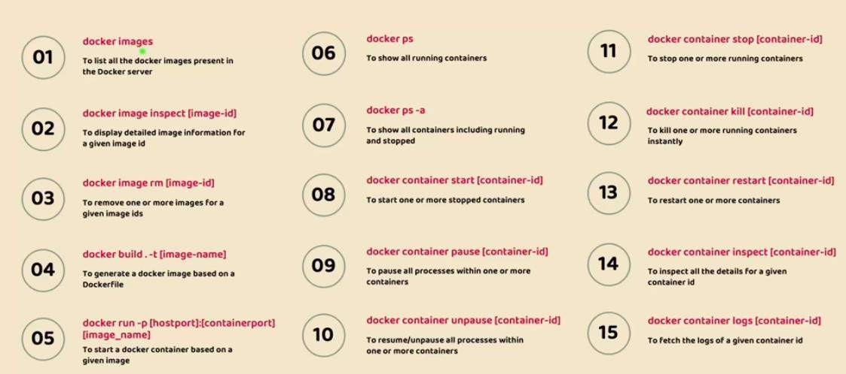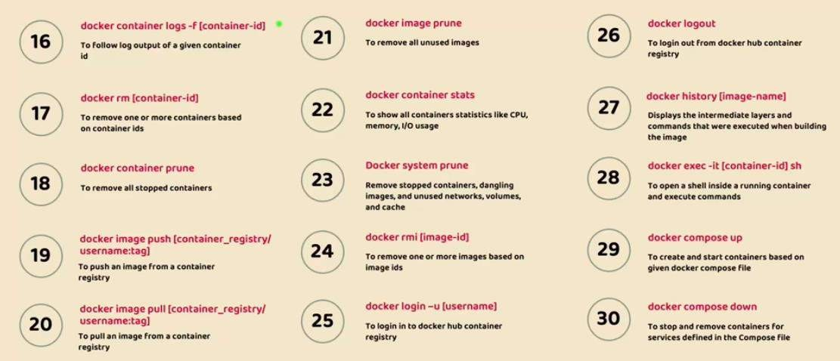

**15th Factors**

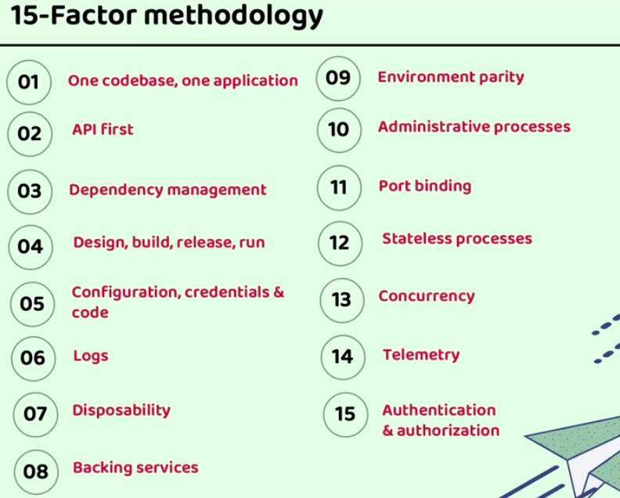

* **Read the properties form the Properties file in the code**

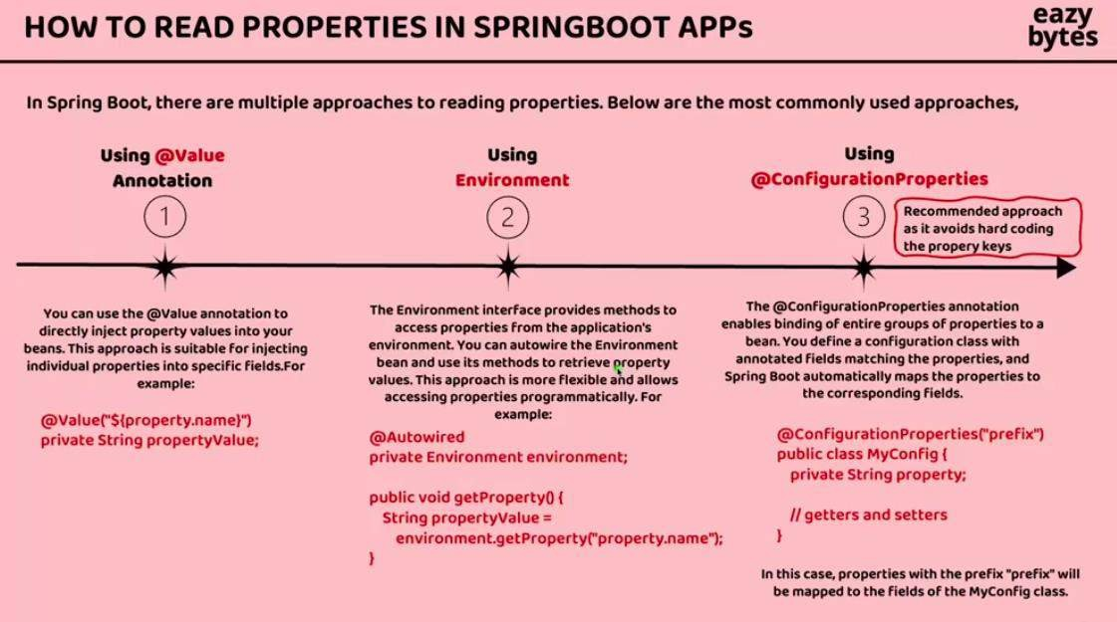

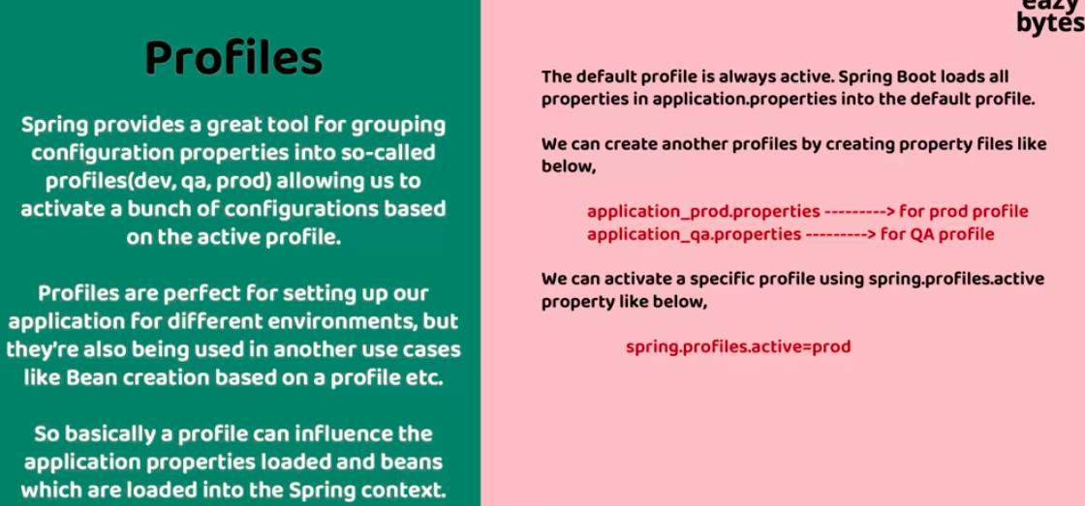**Spring Profile:**

**Take the Arguments from the Comand Line to make it dynamic for all the profiles: Ex: java -jar account.jar --spring.profiles.active=test**

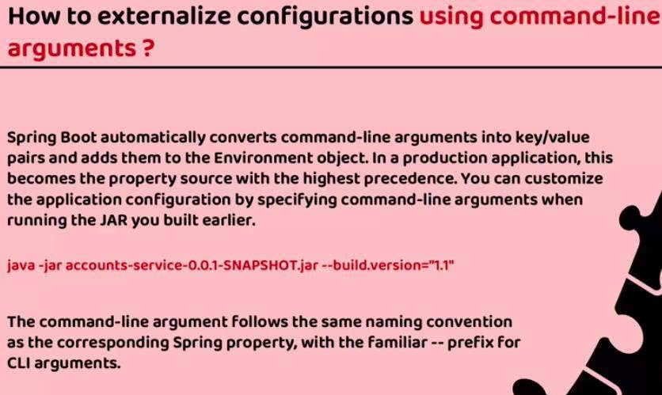

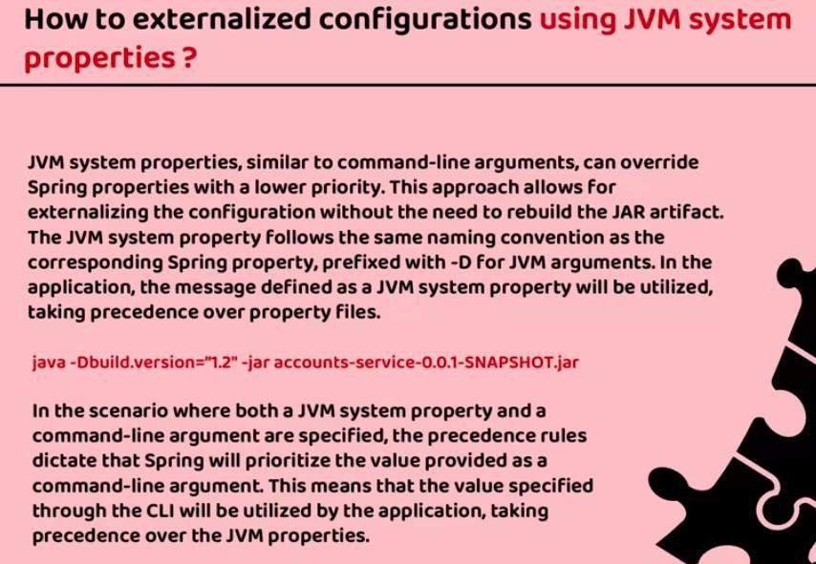

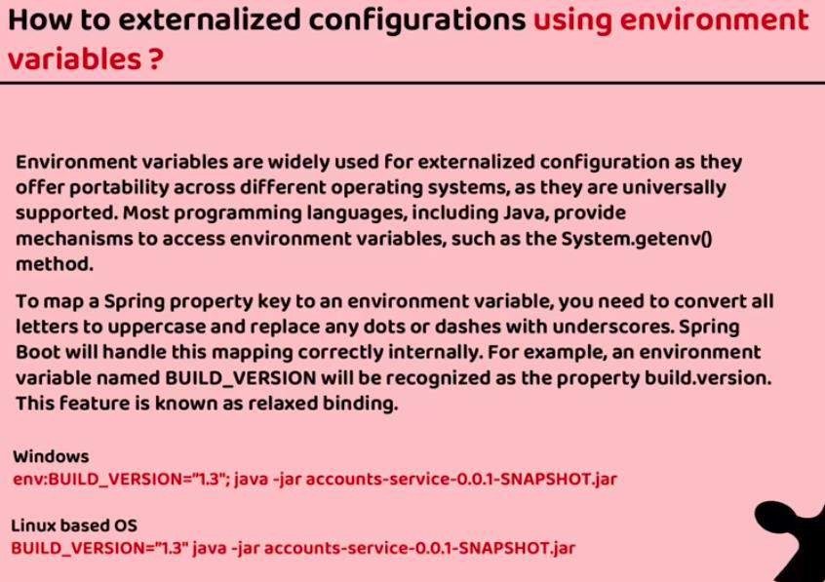

**Centralized Configuration Server:**

<https://spring.io/projects/spring-cloud-config>

## Encrypt and decrypt the properties in the Config Server

Change in the application.properties server:

port: 8071

spring:

application:

name: "configServer"

# used for the classpath and the FileSystem # profiles:

# active: native

# used for the GitRepo profiles:

active: git cloud: config:

server:

# git configuration git:

uri: https://github.com/PriteshDesai/MicroserviceConfig.git default-label: main

timeout: 5

clone-on-start: true force-pull: true

# user for the Classpath and file system. # native:

# use to read the Configuration file from the classpath in the configServer Microservices # search-locations:

# - "classpath:/config"

# use to read the configuration for the loacl system folders # search-locations:

# - "file:///home//pritesh_desai//Projects//Tainning//MicroserviceUdemy//GlobalConfigDir"

# For the Encryption we use the below properties encrypt:

key: "W9kvPaa0UPUb6DYqDKqMgb7n4R8anNw9"

Encryption API: http://localhost:8071/encrypt

Decrypt API: http://localhost:8071/decrypt

## For Auto reload of the properties in the Config Server

Add the Actuator dependency.

Add the below endpoint to access to reload the configs.

# Enable the auto load the global config without restart the server (this will start the Actuator endpoints)

management:

endpoints:

web:

exposure:

include:

- "*"

Call the POST API from the postman http://localhost:8080/actuator/refresh

For the auto reload all the microservices we need **Spring cloud bus** for that we need the rabbitMQ install in the local system.

<https://www.rabbitmq.com/download.html>

-> rabbitMQ start command in the local system

docker run -it --rm --name rabbitmq -p 5672:5672 -p 15672:15672 rabbitmq:3.12-management

-> add the configuration properties of the rabbitMQ and Spring cloud bus. Add dependency to all the micro services.

<!-- https://mvnrepository.com/artifact/org.springframework.cloud/spring-cloud-starter-bus-amqp

-->

<dependency>

<groupId>org.springframework.cloud</groupId>

<artifactId>spring-cloud-starter-bus-amqp</artifactId>

<version>4.0.1</version>

</dependency>

-> add the **application.property**

#RabbitMq configurations for the auto reaload the configurations spring:

rabbitmq:

host: "localhost" port: 5672 username: "guest" password: "guest"

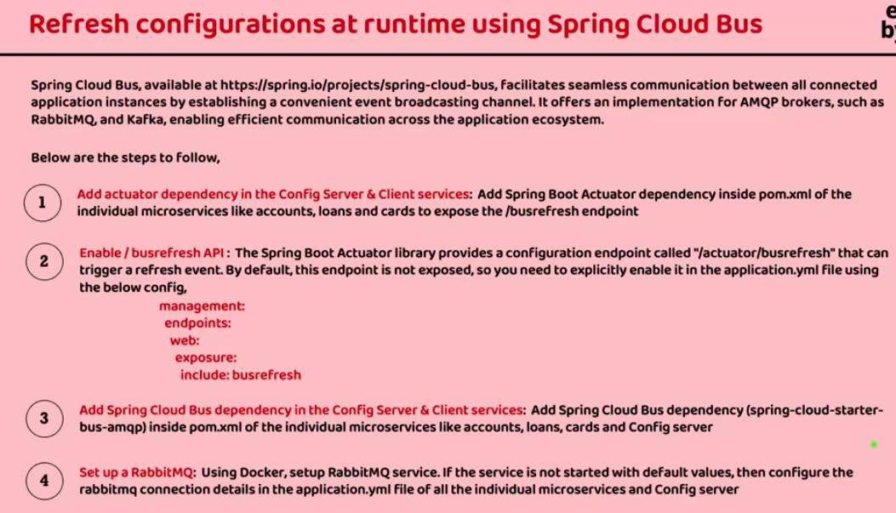

API To Referesh from the all the Micro Services:

POST API: http://localhost:8080/actuator/busrefresh

## For the Automatic Refresh without call the BusRefresh API:

We create the WebHook When any change in the github then we call the API for refresh the configuration automatically.

Add the below dependency in config micro service:

<!-- https://mvnrepository.com/artifact/org.springframework.cloud/spring-cloud-config-monitor -->

<dependency>

<groupId>org.springframework.cloud</groupId>

<artifactId>spring-cloud-config-monitor</artifactId>

<version>4.0.4</version>

</dependency>

# Enable the auto load the global config without restart the server (this will start the Actuator endpoints)

management:

endpoints:

web:

exposure:

include:

- "*"

Create the WebHook in the GitHub repository.When the Change in the WebHook it Automatically run the API. <https://github.com/PriteshDesai/MicroserviceConfig/settings/hooks/new>

In Web hook we need the Dynamic Ip We don’t use the static IP (localhost). For the Testing purpose in localhost we use the https://hookdeck.com/ . <https://console.hookdeck.com/>

Download the Latest Hook Deck and run the installation command.

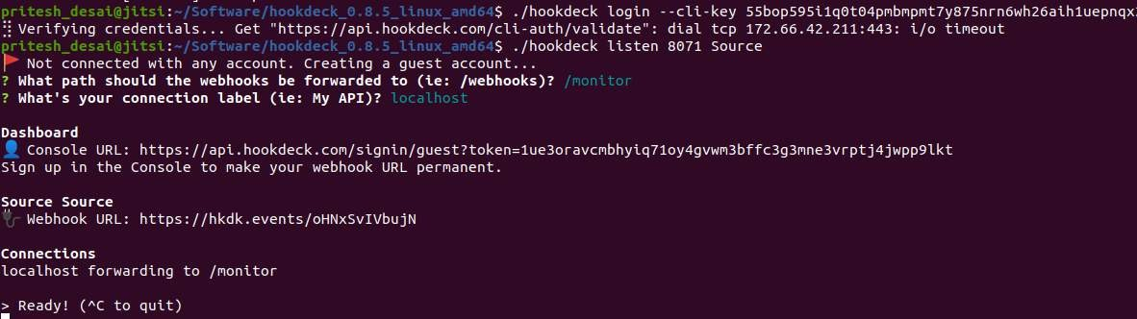

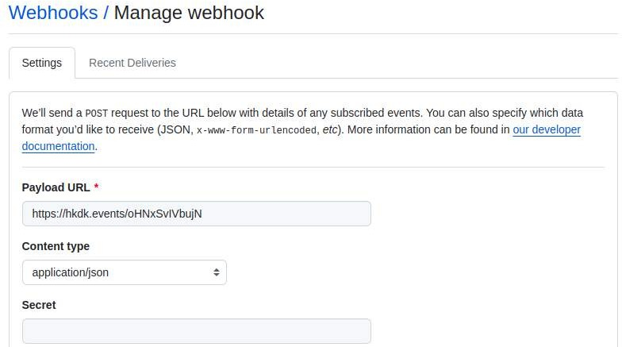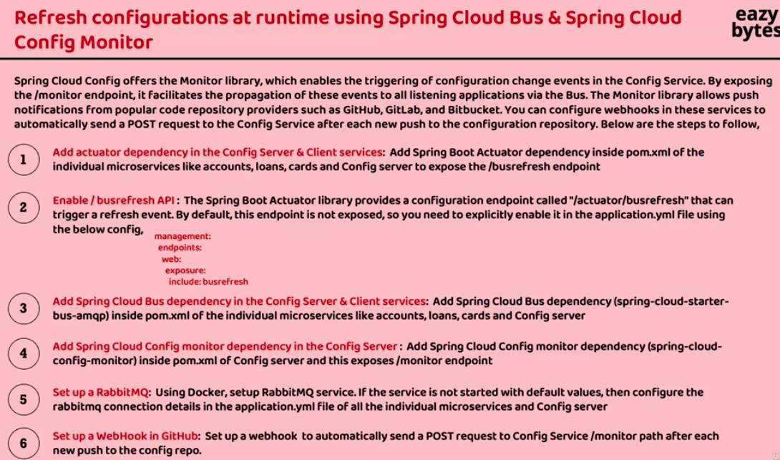

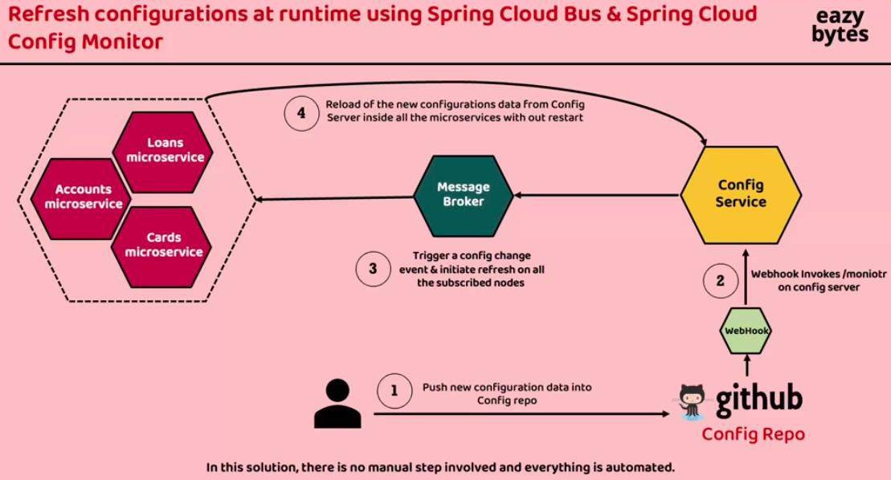

Create the Docker-Compose file for Deploy all the Docker Images,

Create the Folder in the Soure “docker-compose” follow by the folder of your environments.

Ex: docker-compose->dev, docker-compose-> prod, docker-compose->default Default is used for the default configurations.

Add the below things in the docker-compose.yml file

Add the ConfigServer image add, add the configuration to read the configuration in other files.

=> Config Server Change services:

configServer:

image: "priteshdesai1811/configServer:s6" container_name: "configServer-ms"

ports:

- "8071:8071"

deploy:

resources:

limits:

memory: 700m networks:

- brainvire

=> Add the configurations in all the service config yml files

# add the enviroments for the Docker Image enviroment:

SPRING_ACCOUT_NAME: "accounts" # configserver: is prefix

# configServer: is the Server name used in the yml file SPRING_CONFIG_IMPORT: "configserver:http://configServer:8071/" SPRING_PROFILE_ACTIVE: default

=> on issue here, We ned to wait the another image to start till the Config server service is start in the Docker-compose file

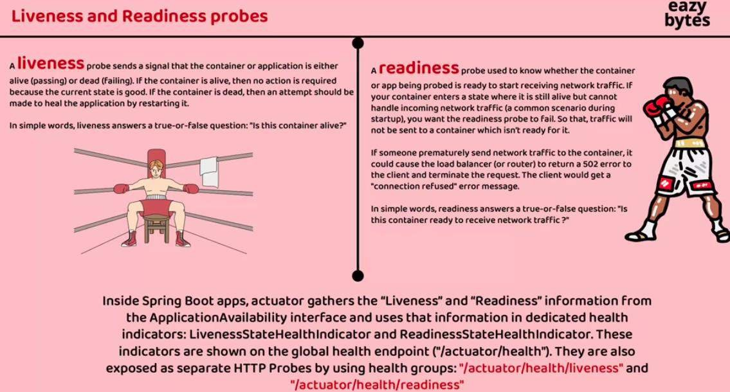

Change the Liveness and readiness related change in the compose file:

Change the application.yml file and add the below property management:

health:

readinessstate:

enabled: true livenessstate:

enabled: true endpoint:

health:

probes:

enabled: true

## Mysql Conection in the All the Application using the docker.

We need to disable the rabbitmq auto reload the property because it load to much resources.

Run the Sql with the docker image

>> docker run -p [port:port] - -name [dbName] -e MYSQL_ROOT_PASSWORD=[sqlPassword] - e MYSQL_DATABASE=[dbName] -d [dockerImageName]

>> docker run -p 3306:3306 - -name accountsdb -e MYSQL_ROOT_PASSWORD=root -e MYSQL_DATABASE=accountsdb -d mysql



It will show in the container list

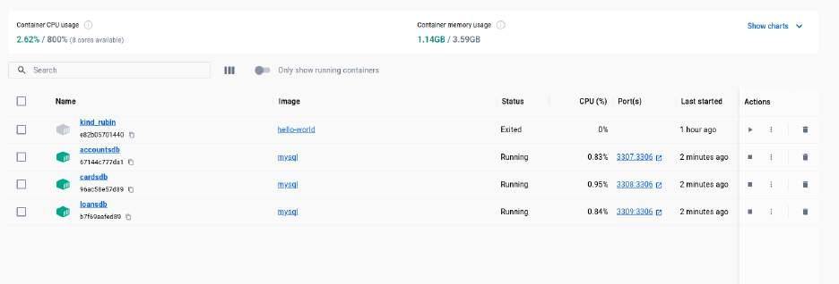

Need to manually start all the docker db that is not suitable for the real scenario.

Need to update the docker-compose file for the host name and database configurations. And also it able to start all the db container automatically.

## Service Registry / Service Discovery(Eureka Server):

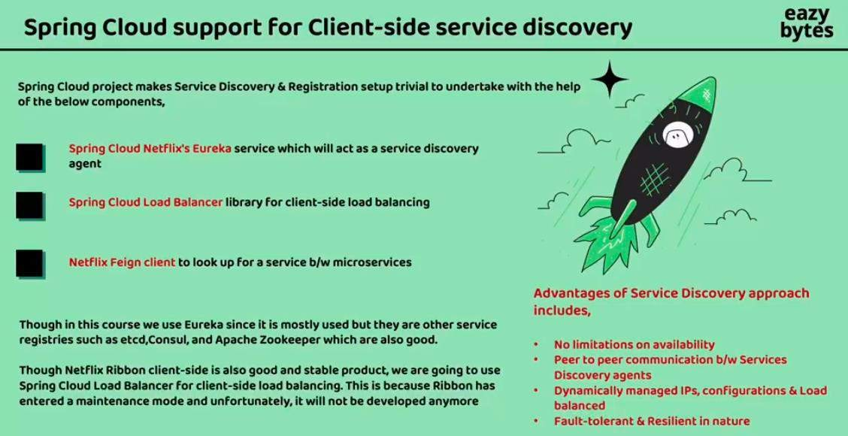

**Get the Lost of APPs register in the Eureka server**

http://localhost:8070/eureka/apps

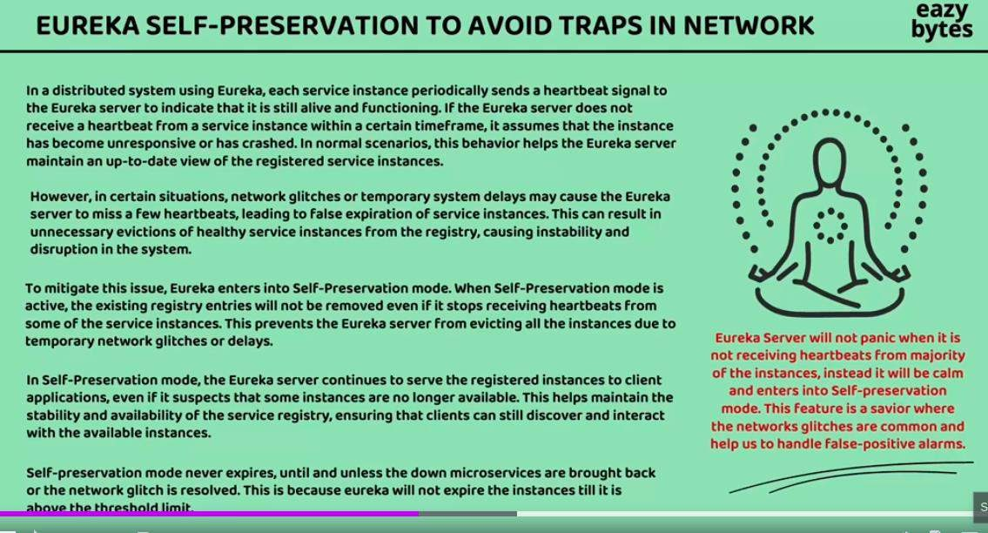

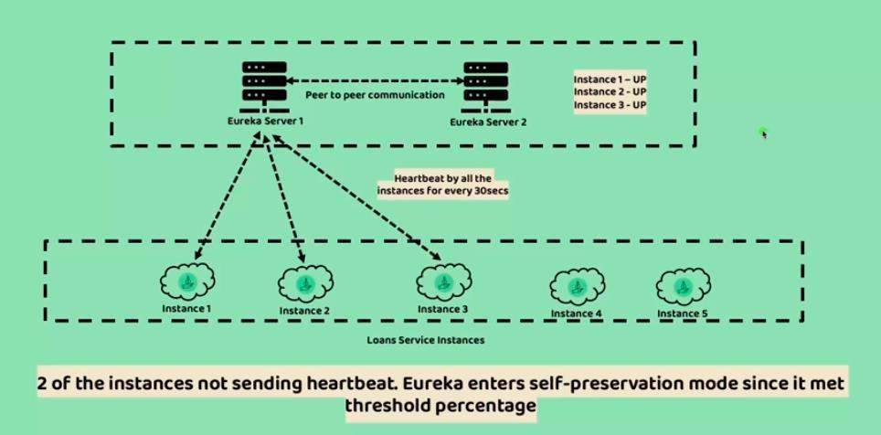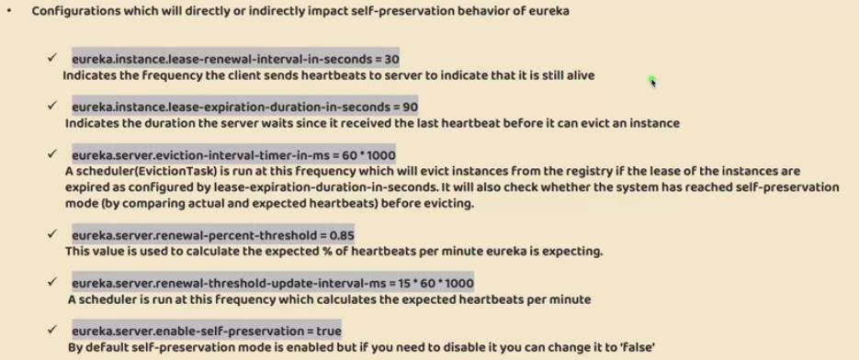

## API GateWay (Edge Server):

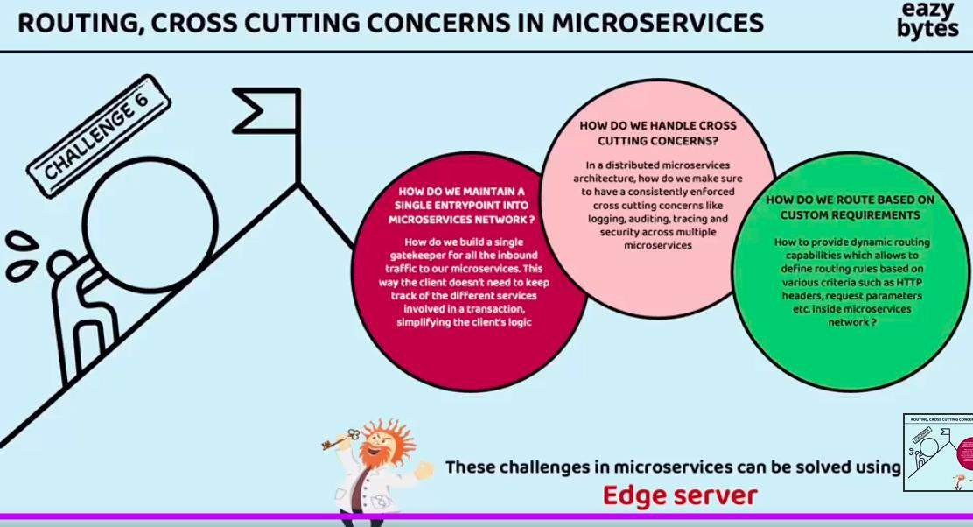

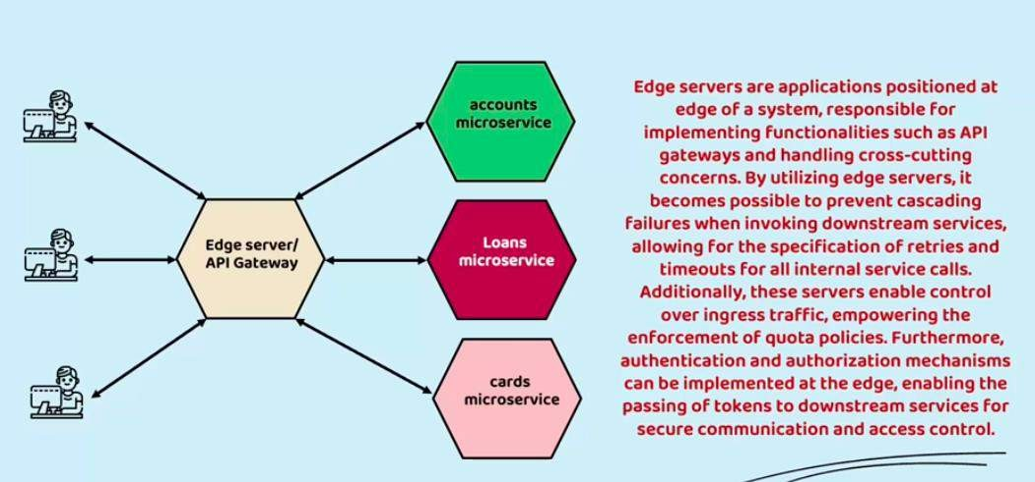

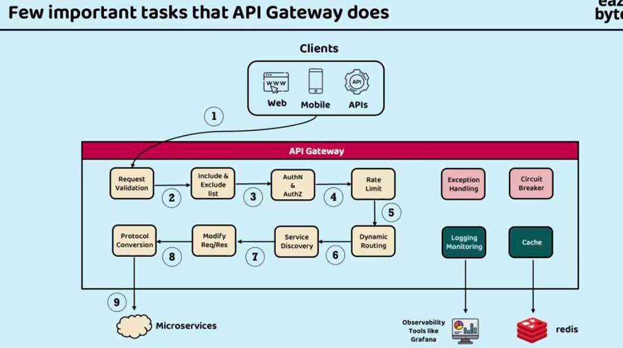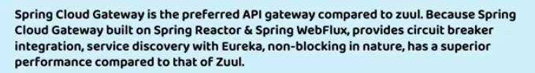

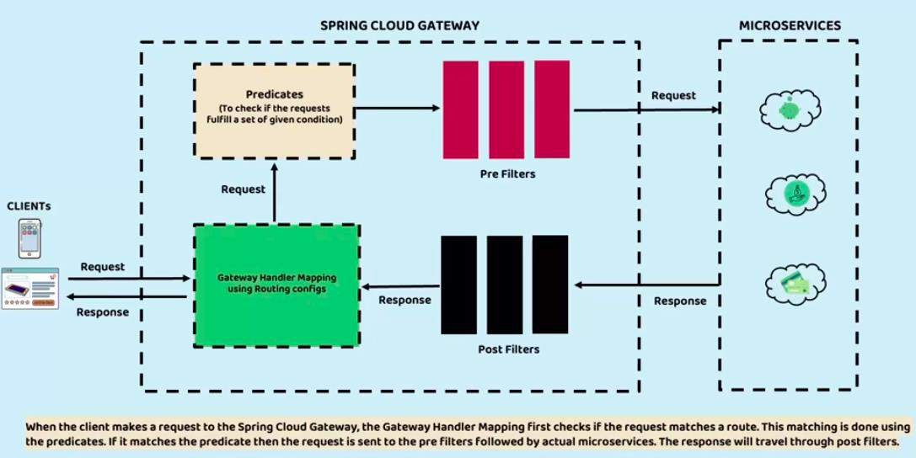

Spring cloud Gateway official Document:

<https://docs.spring.io/spring-cloud-gateway/docs/current/reference/html/>

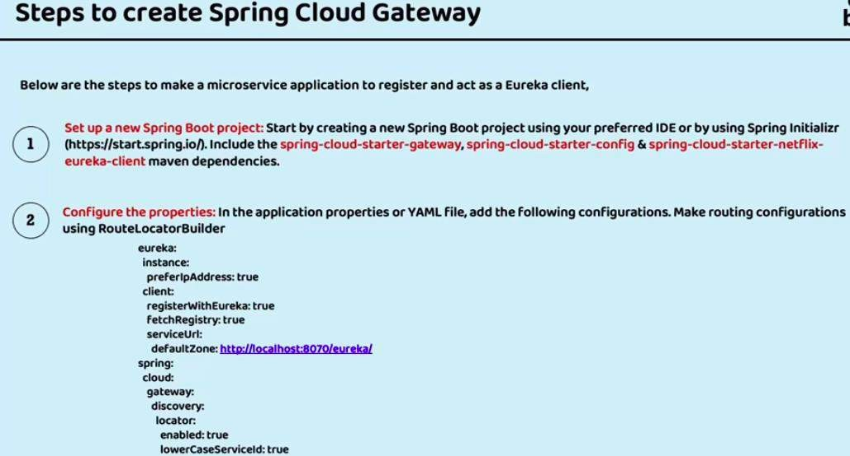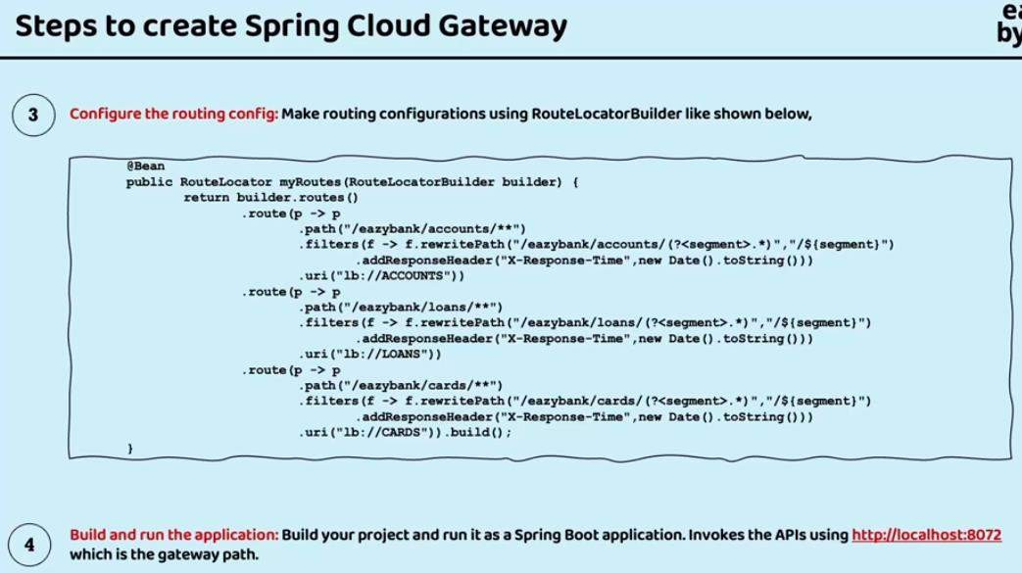

## Resilience Microservice (Fault Tollerance):

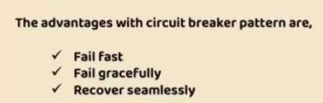**Documentation Link:** <https://resilience4j.readme.io/docs>

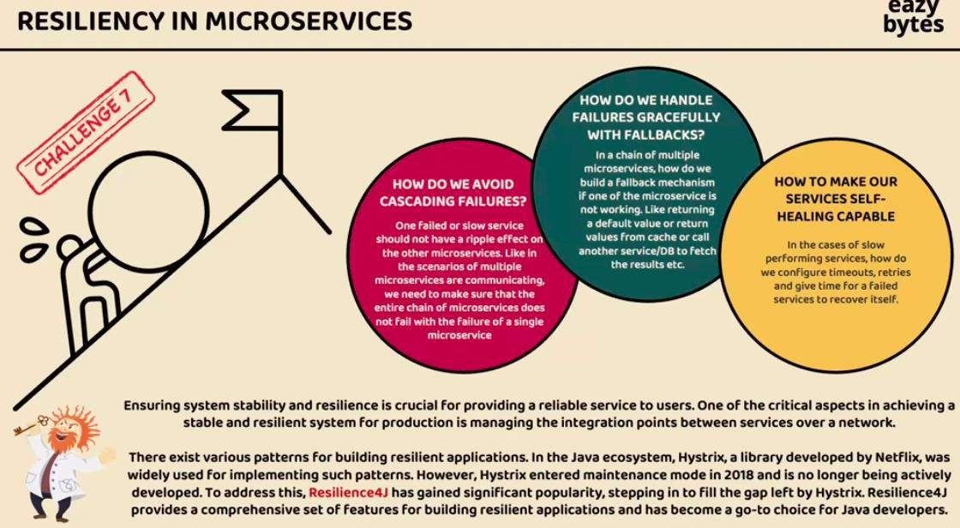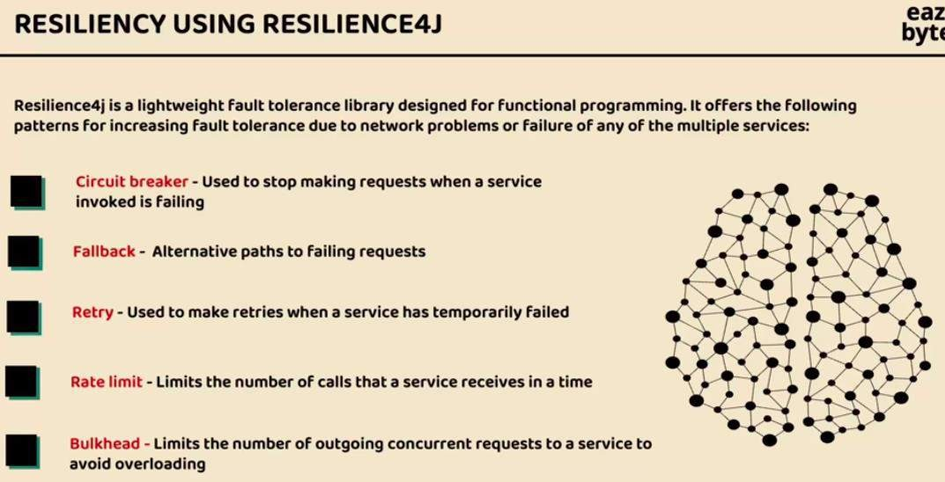

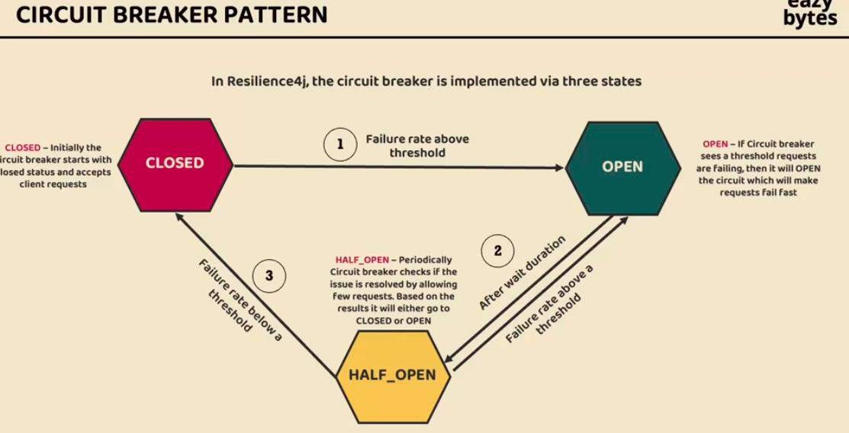

Circuit breaker in the API GateWay <https://docs.spring.io/spring-cloud-openfeign/reference/>

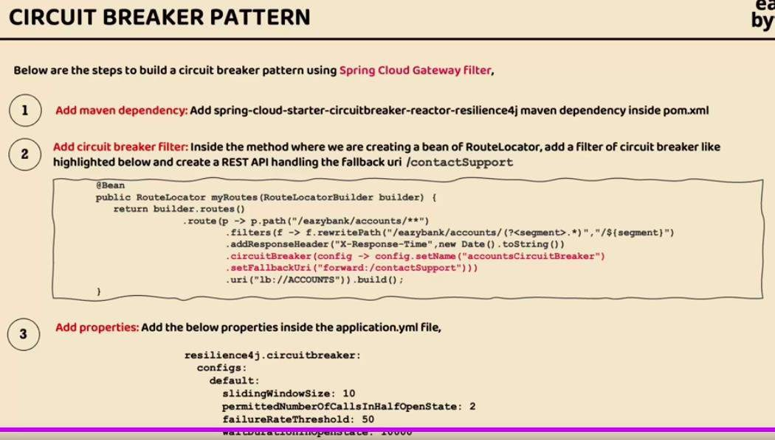

Circuit breker in the accounts misroservice

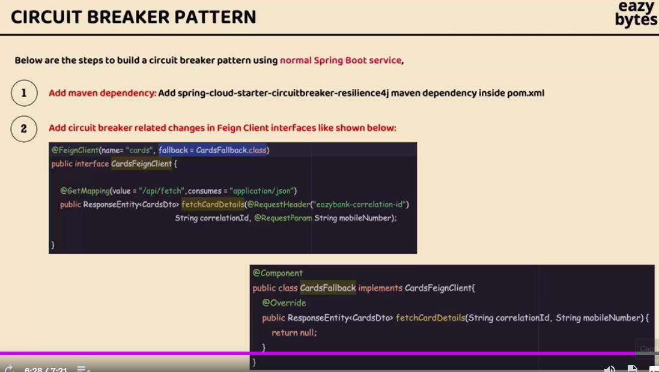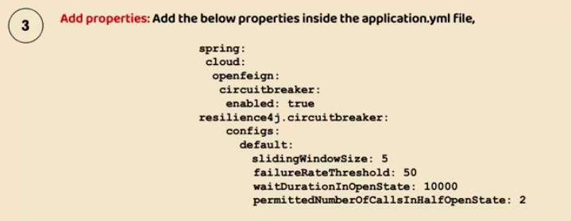

## HTTP Timeout Configuration in the Microservice APIS.

[https://docs.spring.io/spring-cloud-gateway/reference/spring-cloud-gateway/http-timeouts-](https://docs.spring.io/spring-cloud-gateway/reference/spring-cloud-gateway/http-timeouts-configuration.html) [configuration.html](https://docs.spring.io/spring-cloud-gateway/reference/spring-cloud-gateway/http-timeouts-configuration.html)

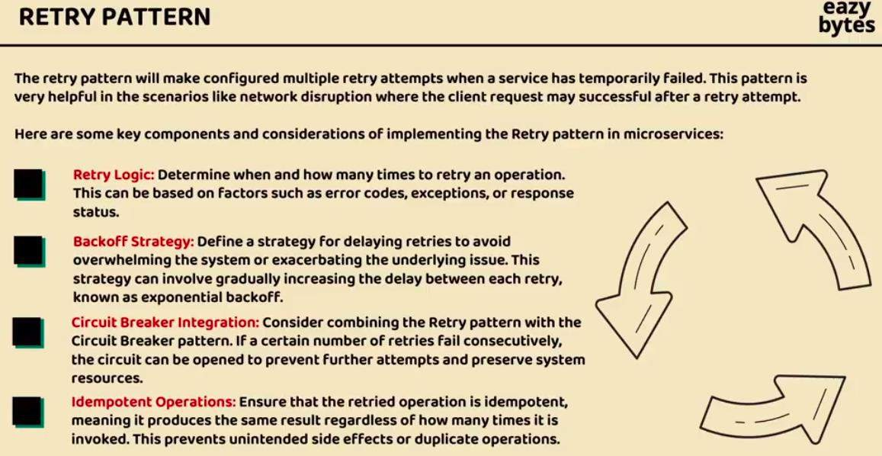

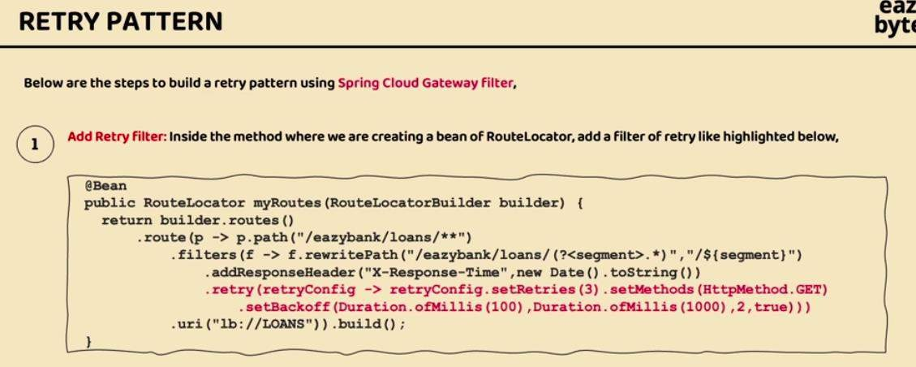

Properties of the retry and circuit breakers: <https://resilience4j.readme.io/docs/getting-started-3>

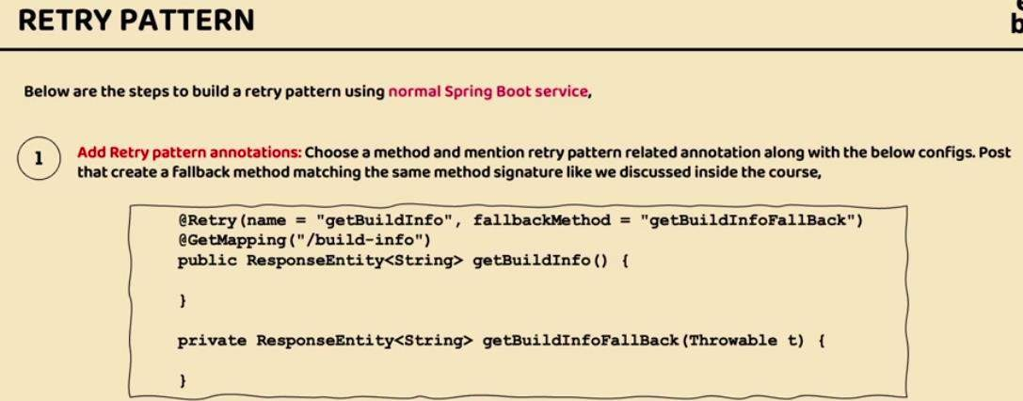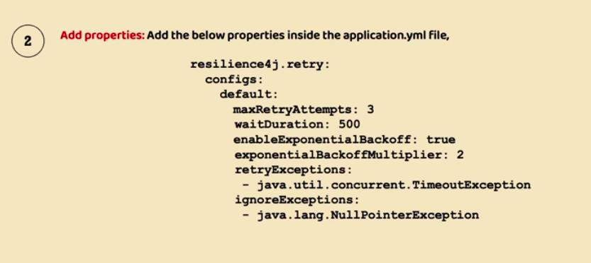

Rate Limitter : [https://docs.spring.io/spring-cloud-gateway/reference/spring-cloud-](https://docs.spring.io/spring-cloud-gateway/reference/spring-cloud-gateway/gatewayfilter-factories/requestratelimiter-factory.html) [gateway/gatewayfilter-factories/requestratelimiter-factory.html](https://docs.spring.io/spring-cloud-gateway/reference/spring-cloud-gateway/gatewayfilter-factories/requestratelimiter-factory.html)

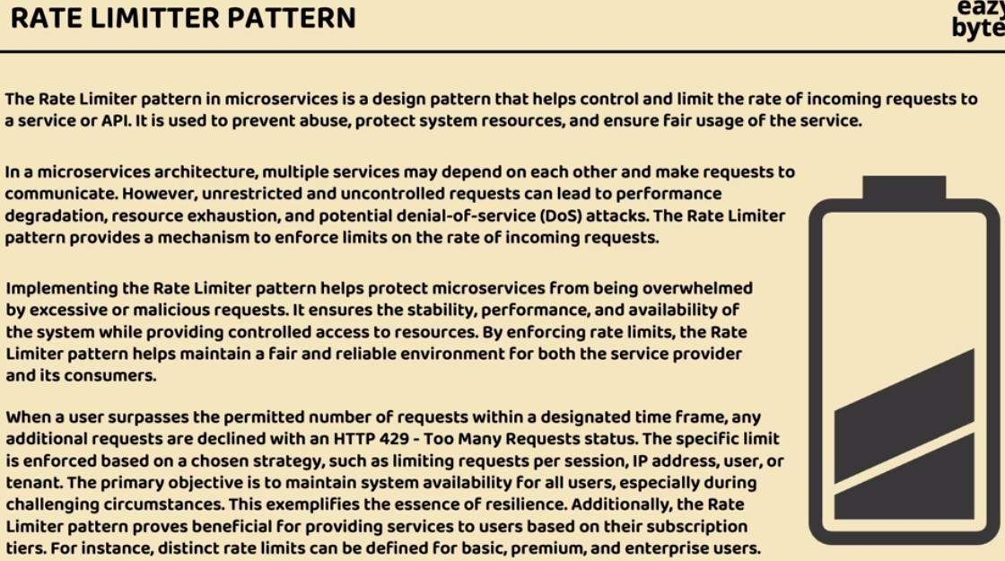

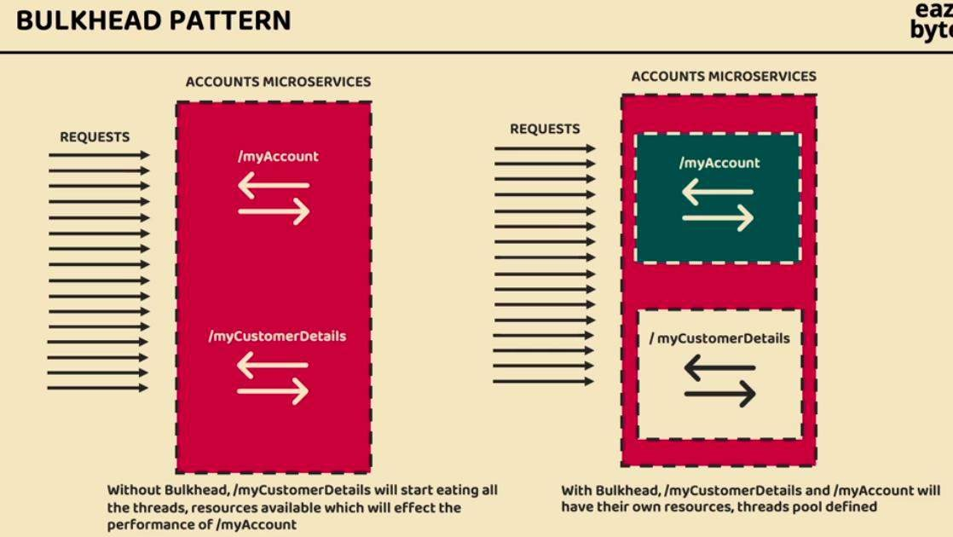BulkHead: <https://resilience4j.readme.io/docs/getting-started-3>

## Observability and monitoring of the microservices:

Monitoring the service using the manually is not possible for the 24*7. We need to automate the process of the monitoring in the microservices. (grafana is used to monitoring and observability).

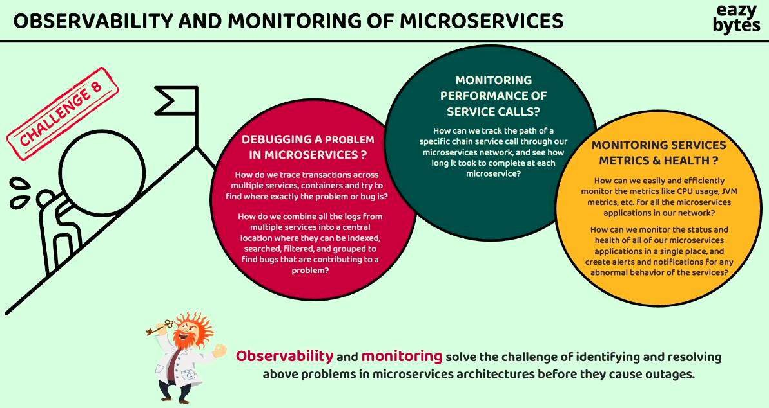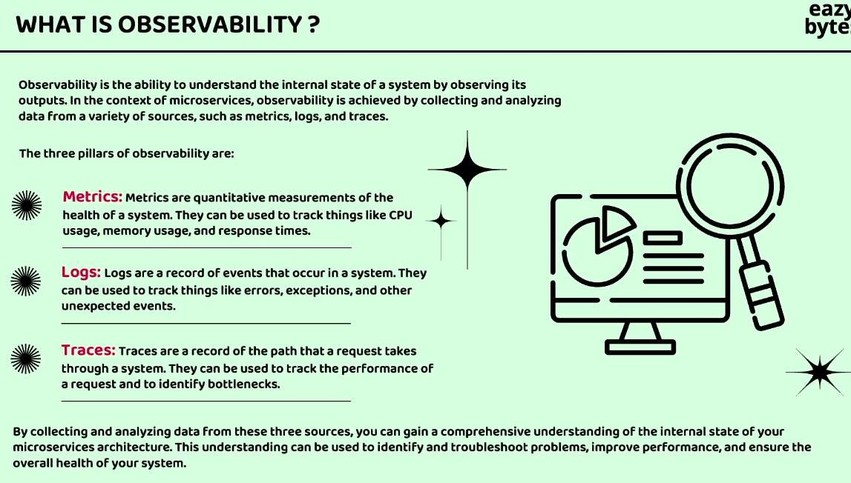

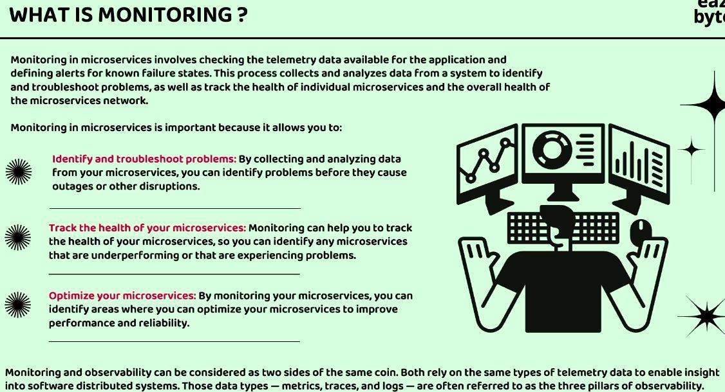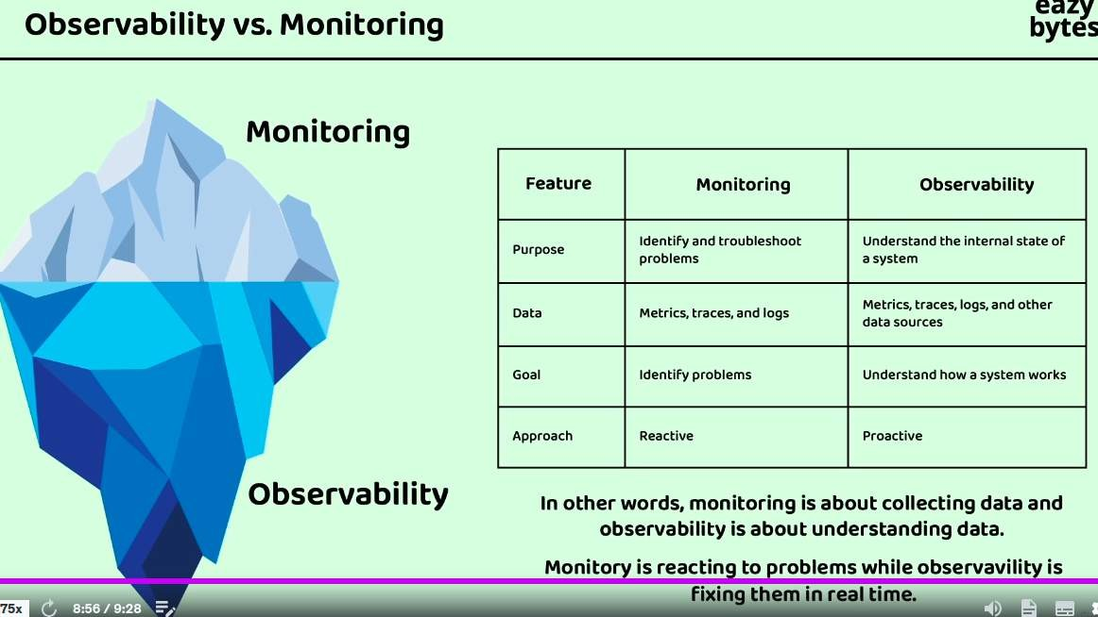

## Event Logs:

Grafana Monitoring Dashboard: <https://grafana.com/> For **Logs**: we use the **Grafana Loki**

For **Monitoring**: we use the **Grafana Prometheus**

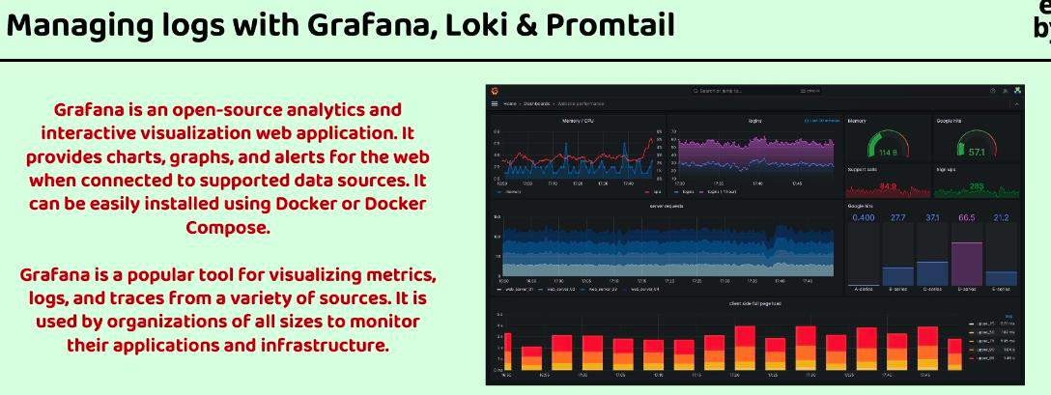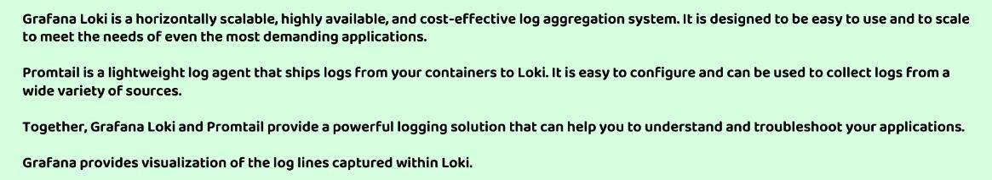

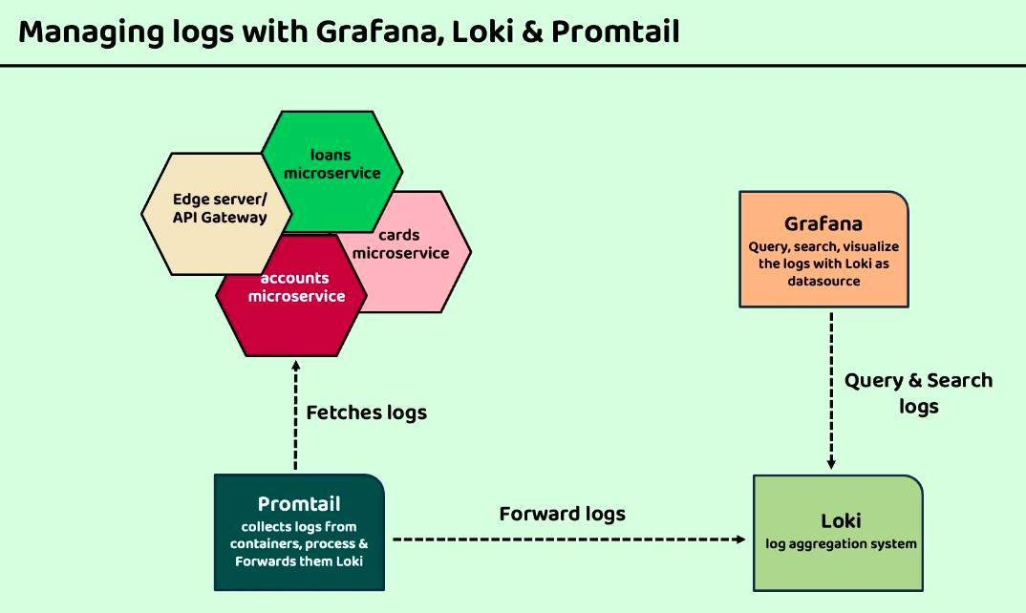

**Grafana Loki Documentation:** Grafana loki we have mapped at localhost:3000 <https://grafana.com/docs/loki/latest/>

Grafana Dashboard to add the different dashboard visualization to Grafana server: <https://grafana.com/grafana/dashboards/>

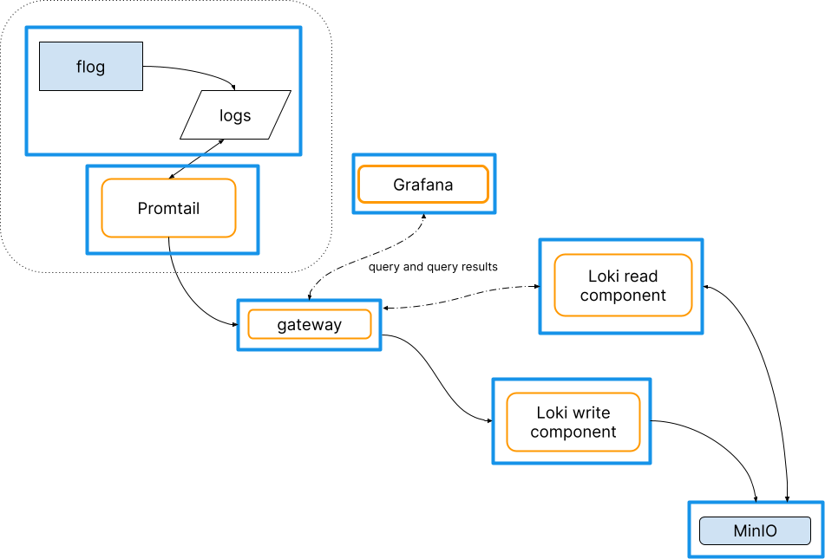

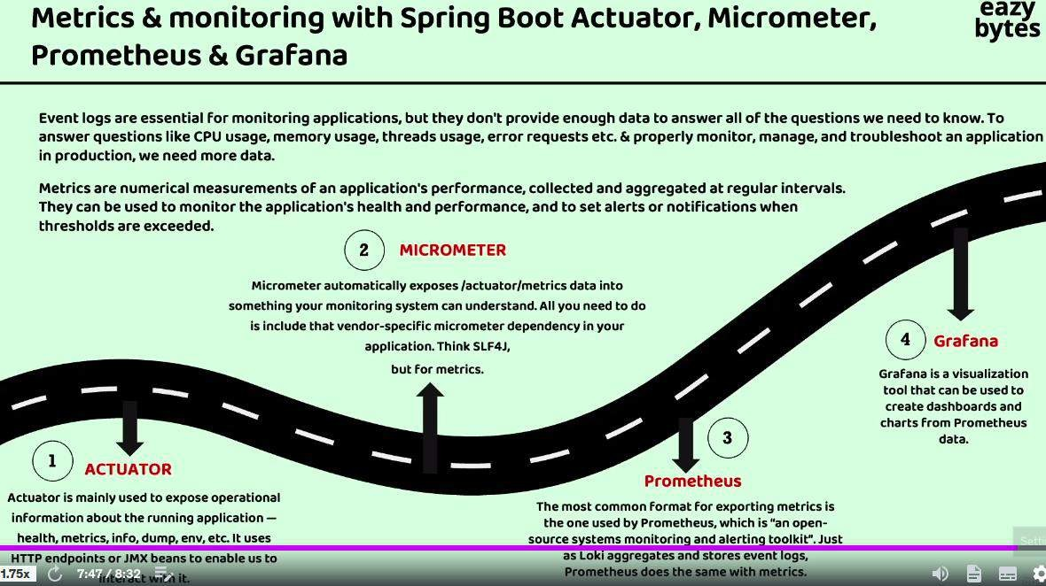

For the **Metrics**

SETUP MICROMRTER::

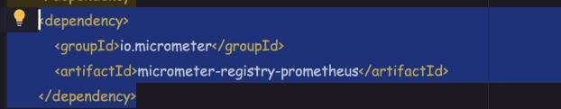add the below dependency and application property to all the micro services.

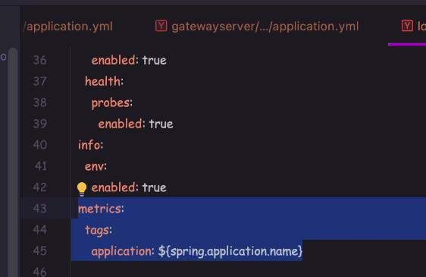Add this properties for identify which metrics used for the which microservices

**Prometheus server**: http://localhost:9090/targets?search= http://localhost:9090/targets?search=

<https://prometheus.io/>

Add the comgfiguration in the config folder and map that in the mail config file of the all the environments.

Video: [https://www.udemy.com/course/master-microservices-with-spring-docker-](https://www.udemy.com/course/master-microservices-with-spring-docker-kubernetes/learn/lecture/39945288#questions) [kubernetes/learn/lecture/39945288#questions](https://www.udemy.com/course/master-microservices-with-spring-docker-kubernetes/learn/lecture/39945288#questions)

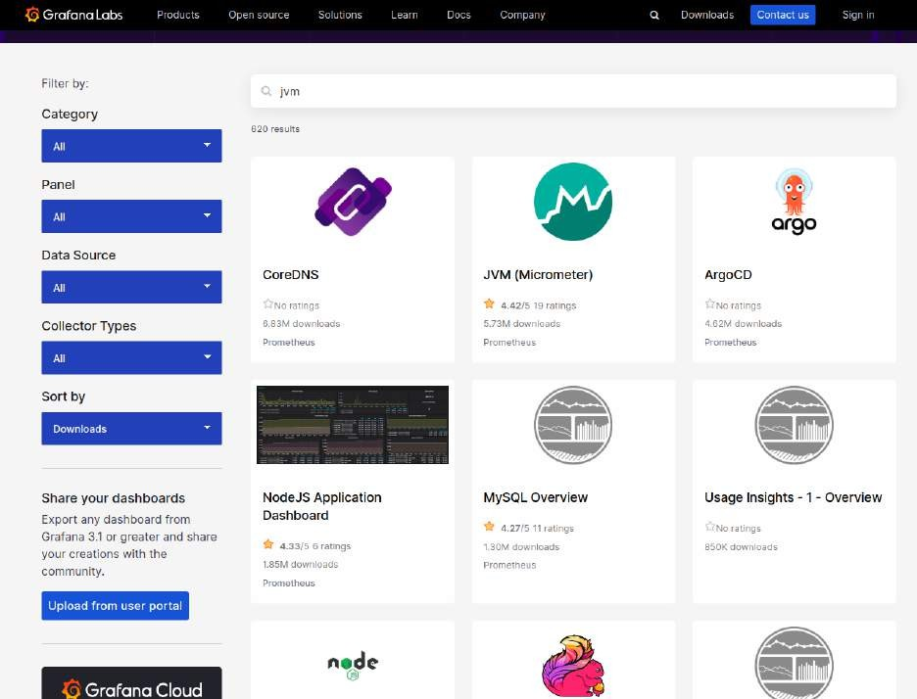

Select the JVM (Micrometer) dashboard.

Copy url: <https://grafana.com/grafana/dashboards/4701-jvm-micrometer/>

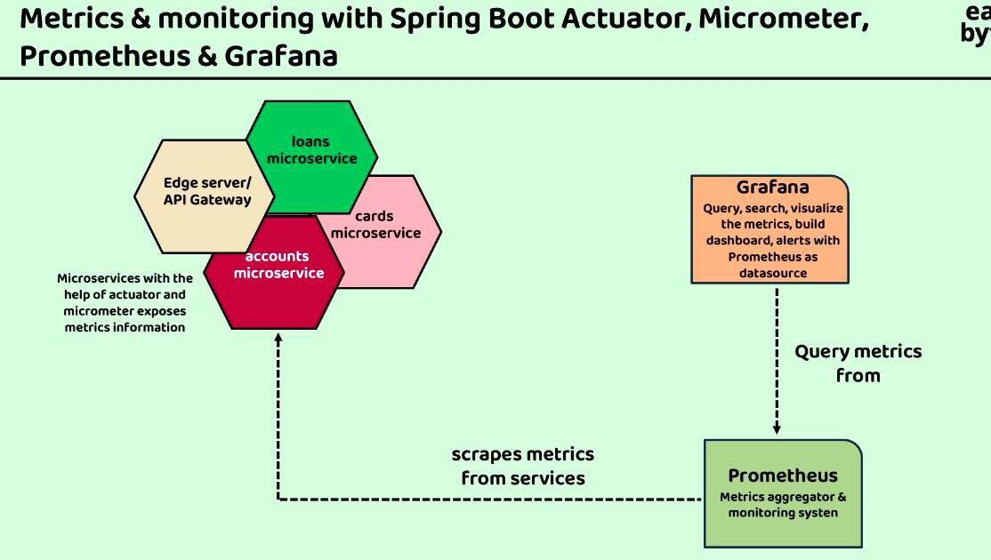

## Traces:

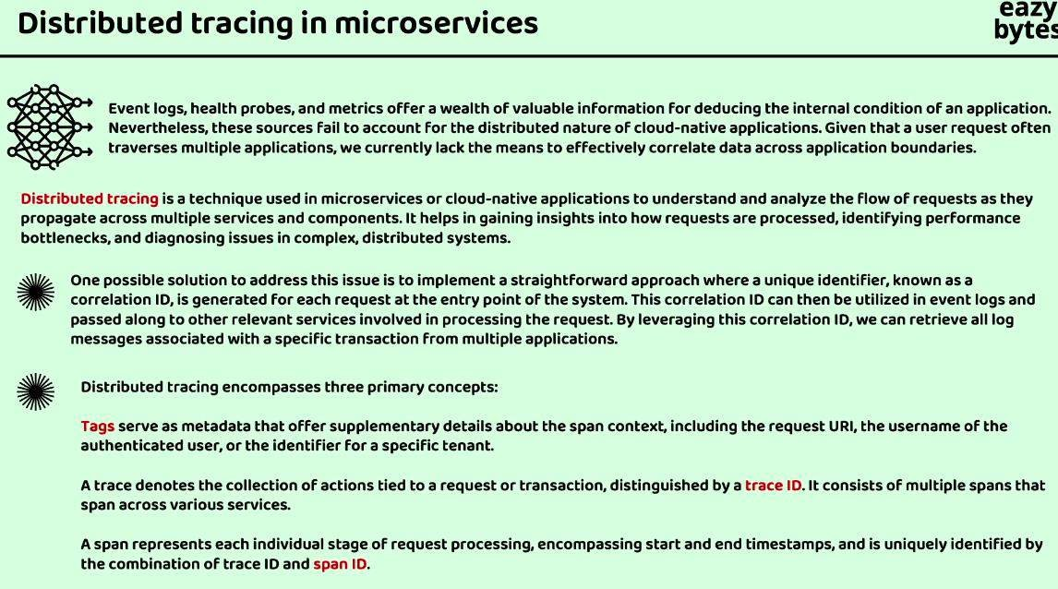

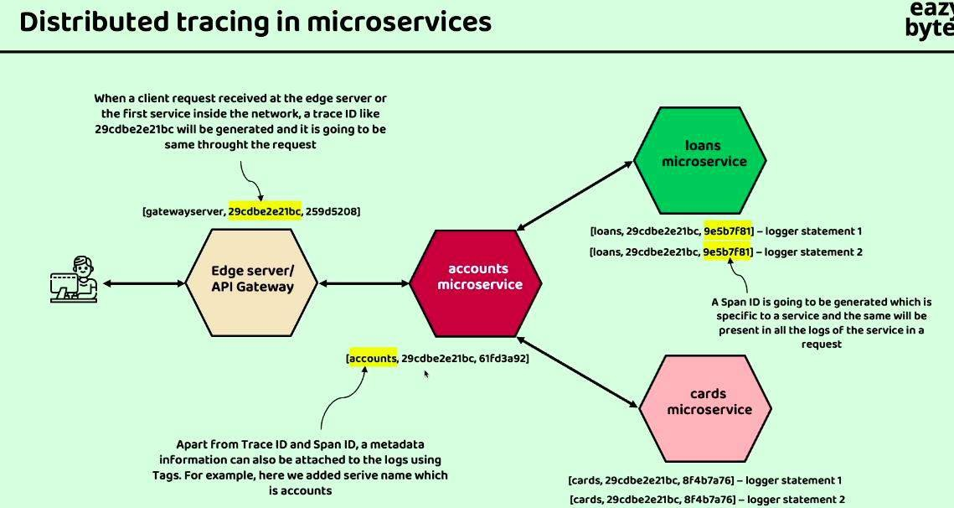

**For Distributed tracing we have following ways:**

1. Spring cloud Sleuth with zipkine <https://spring.io/projects/spring-cloud-sleuth/>

Spring cloud Sleuth and integrate with zipline that automatically add the logs. Spring cloud sleuth and Zipkine are the outdated version so we are not using that.

1. opentelemetry <https://opentelemetry.io/docs/instrumentation/java/automatic/> <https://opentelemetry.io/>

pom.xml

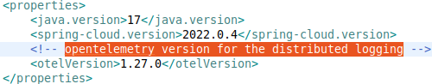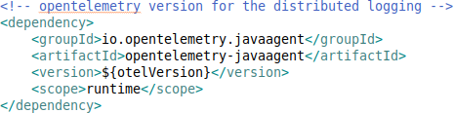

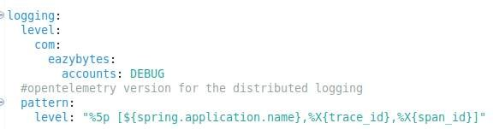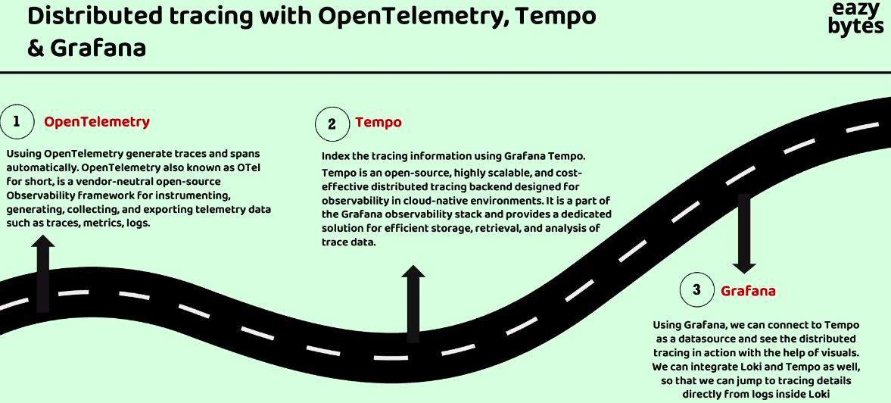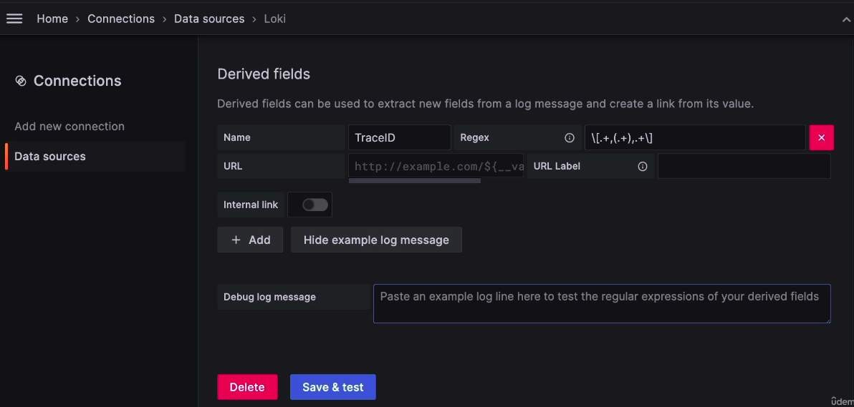application.yml

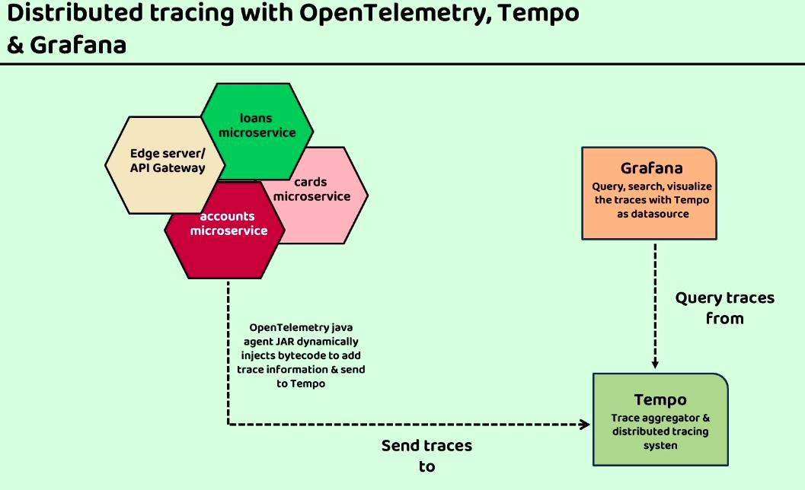

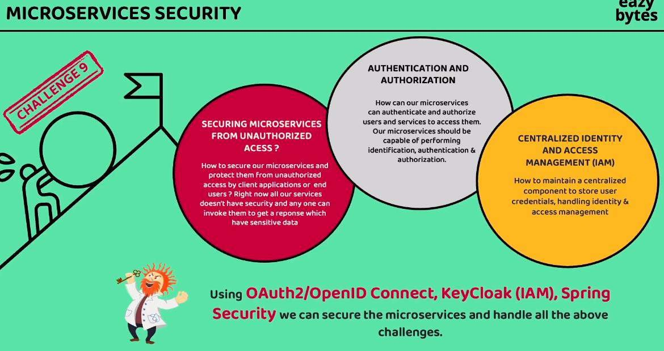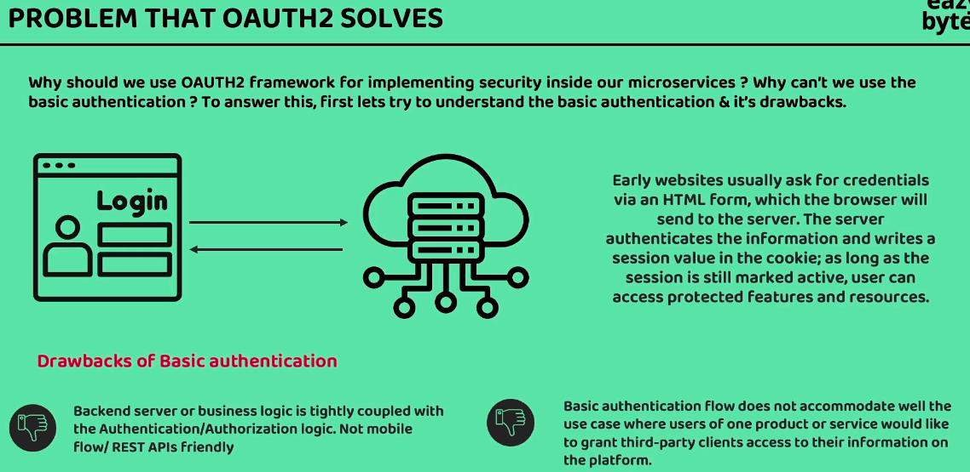**Microservice Security:**

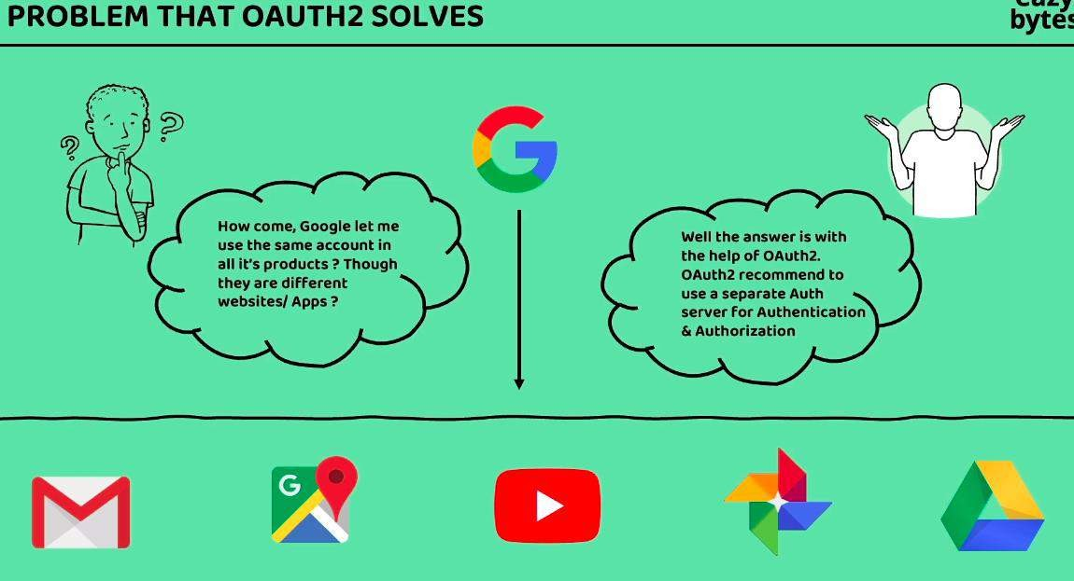

Social Meadia login is the Good Example for the oauth2 problem to solve.

Ex: Instagram use login with the Gmail/facebook option so Instagram can use te same gmail and facebook account with out provide the creds to the instagram.

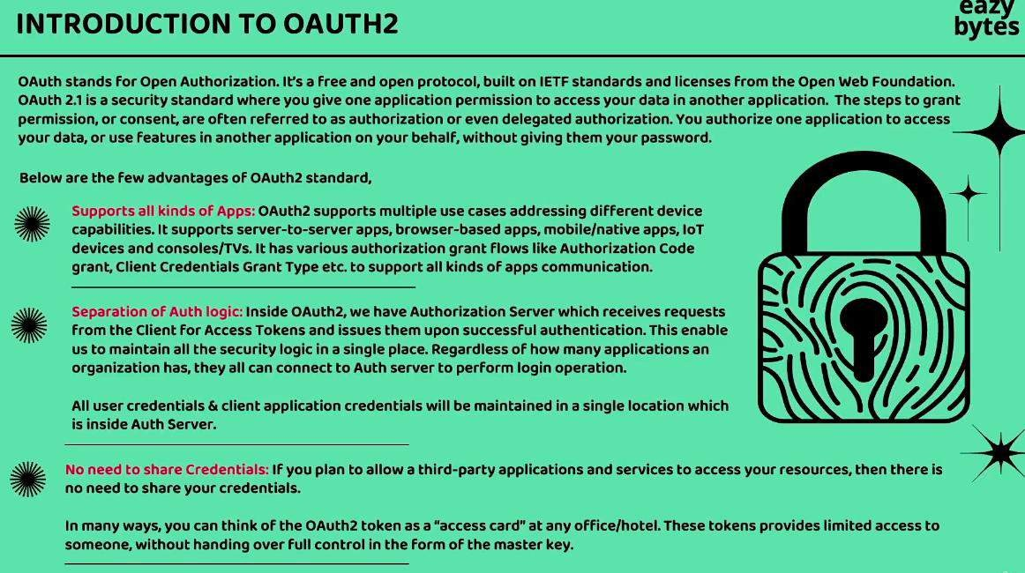

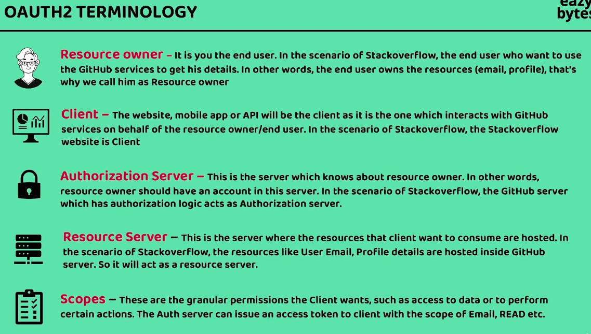

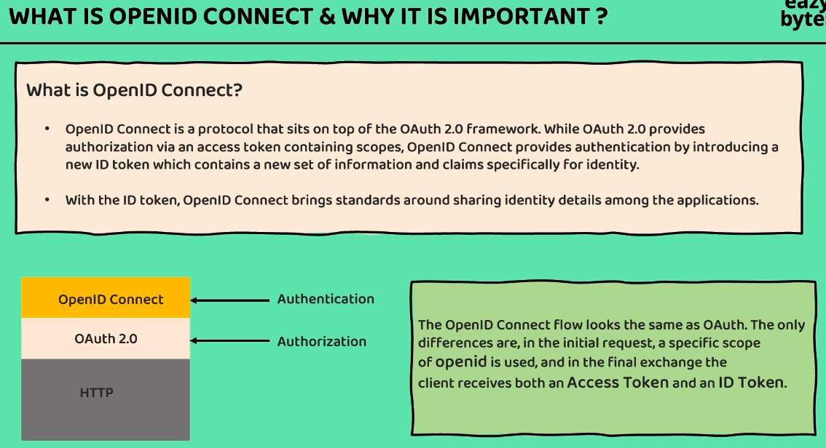

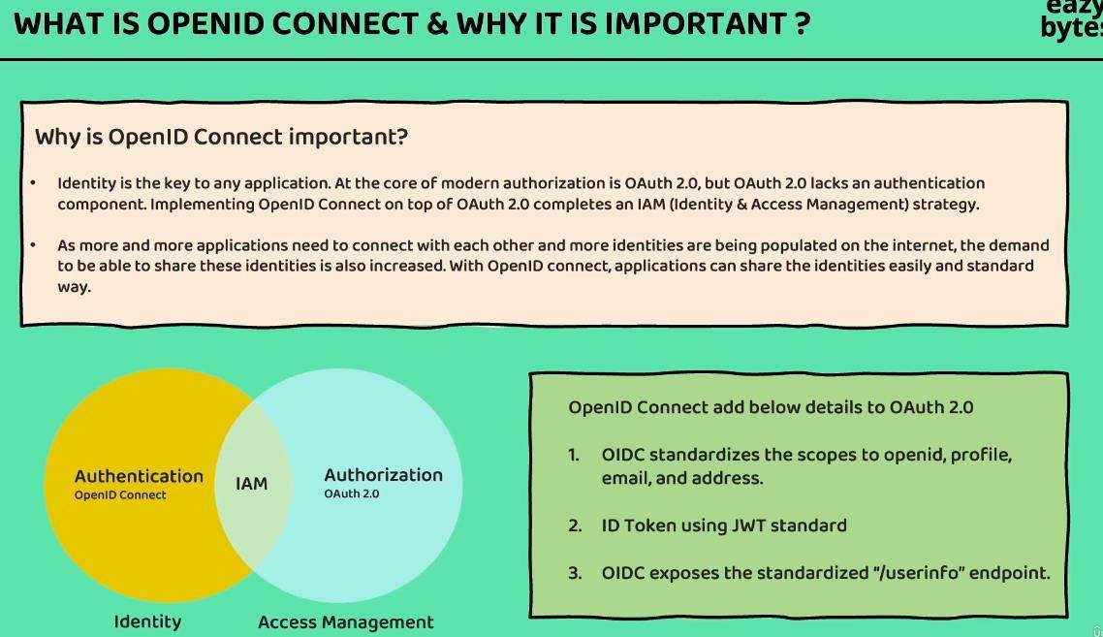

Oauth2.0 and openId Connect is the Specification. Using the Specification we need to implement the security in the application.

Keyclock, octa, AWS Cognito, FusionAuth, ForgeRock is the predefine server for the authorization. We can directly use there services.

Define our custom server then we use Spring authorization server. <https://spring.io/projects/spring-authorization-server/>

Keyclock is opensource Identity and Access Management. Keyclock has perdefine Authorizarion server which includes many services as below.

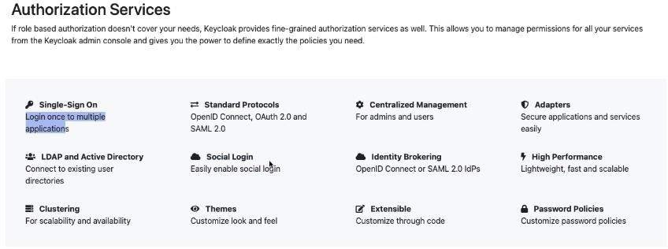

Client Credential Grant Type: Is used when there is two backend service are coordinate with each others.

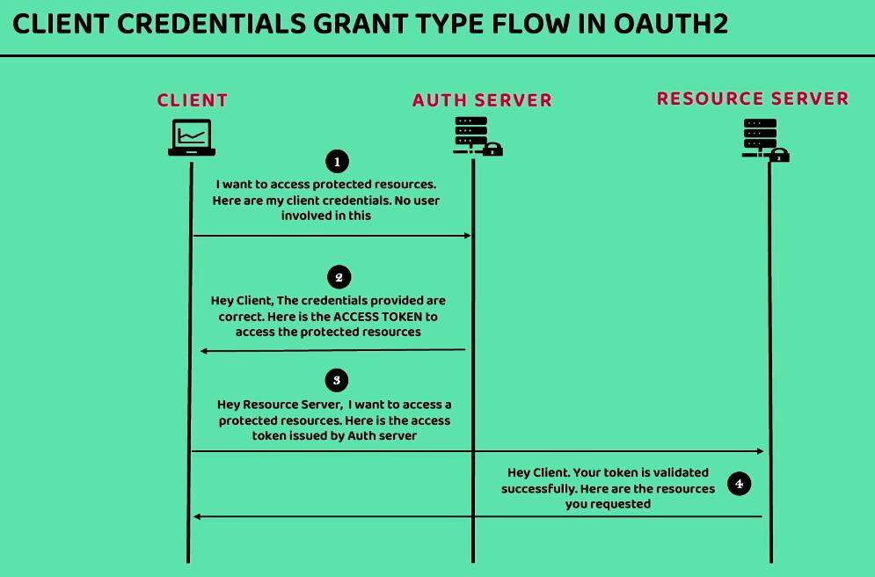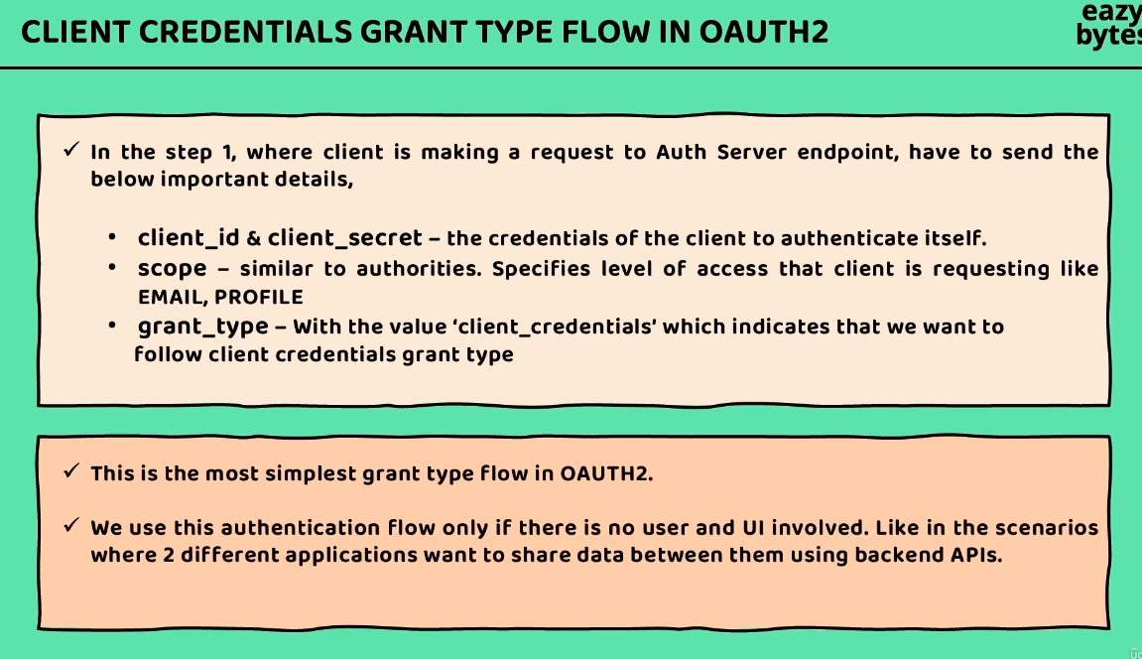

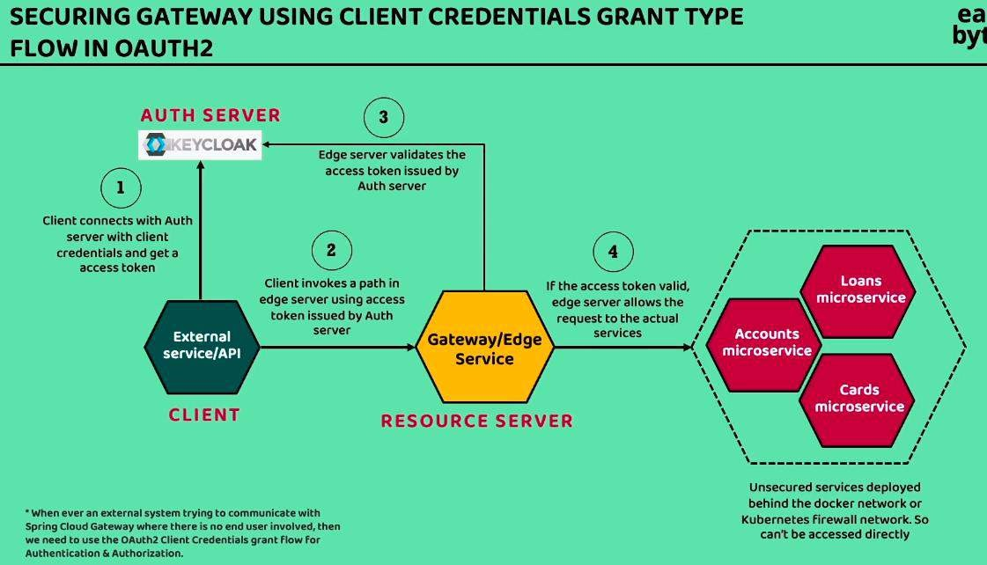

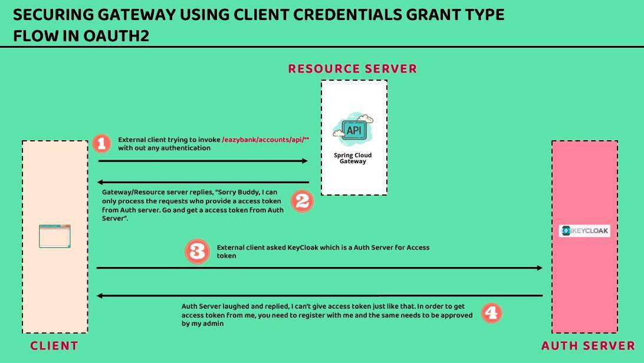

Wrong Clint access the API with the wrong Access token.

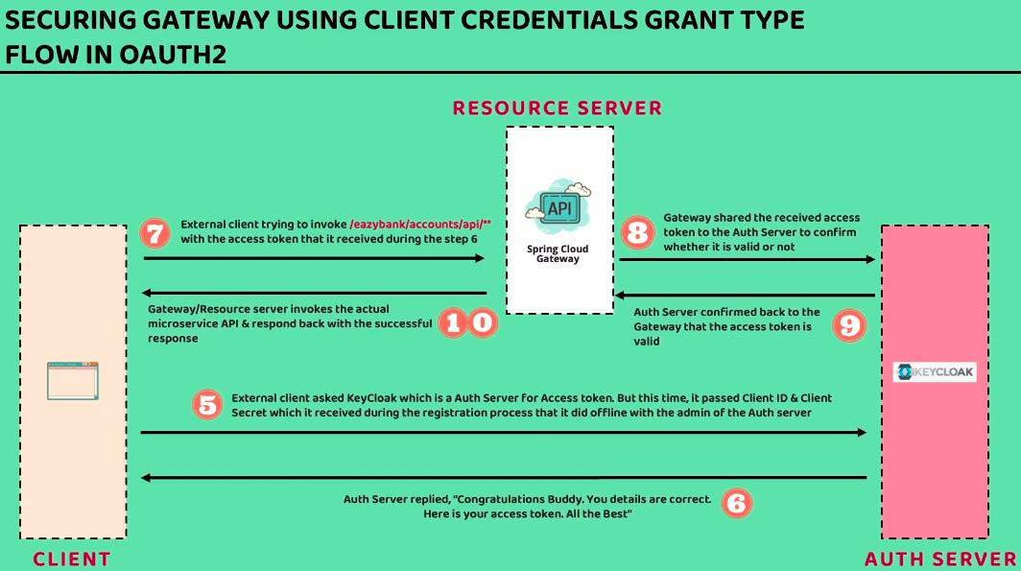

## Keyclock Setup

<https://www.keycloak.org/getting-started/getting-started-docker> Start the keyclock server with the Docker.

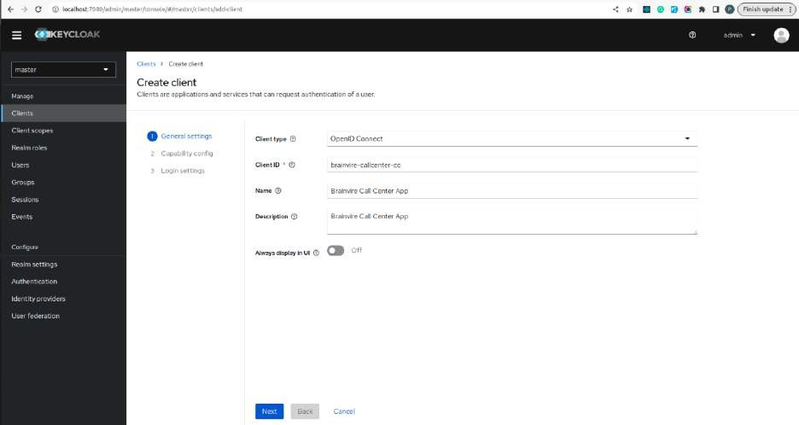

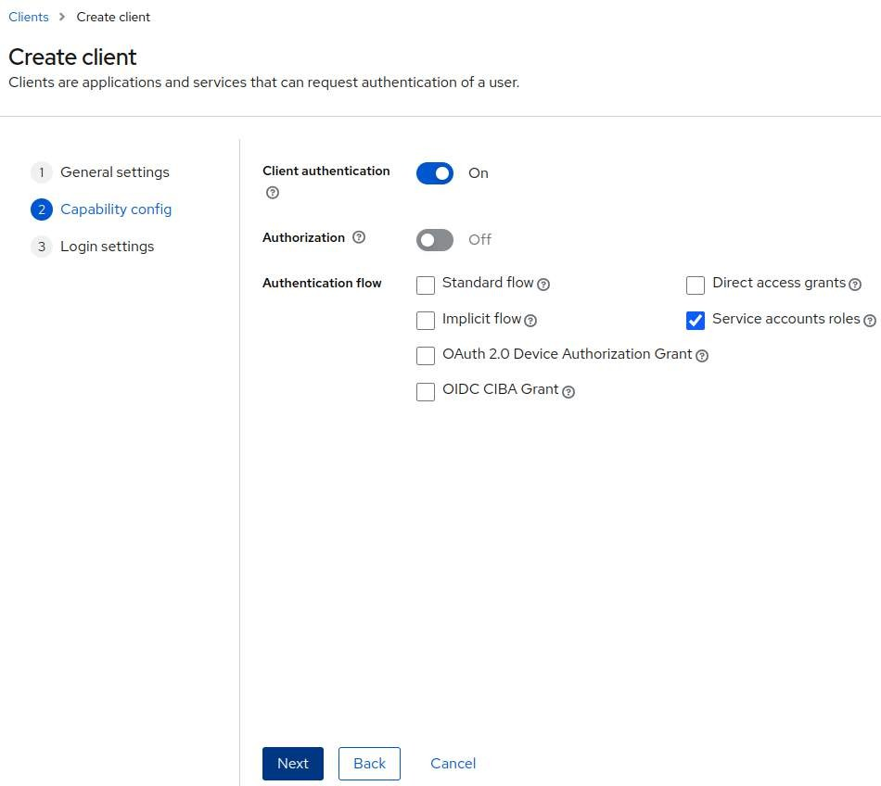

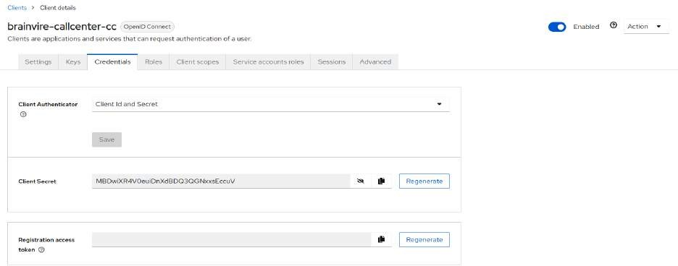

**Client Secret:** MBDwiXR4V0euiDnXdBDQ3QGNxxsEccuV

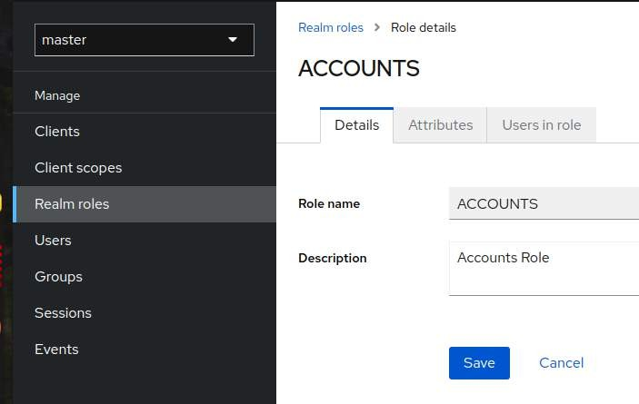Create new role for the role base authentication

Assign the role in the client service account roles

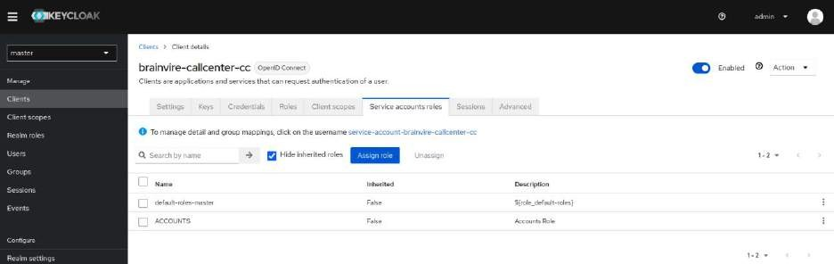

## Authorization Grant Type in oauth 2.0:

It is used when one service is using the another service. Ex: github login with the gmail. Here client: github

Authserver: oauth 2.0 (Keyclock)

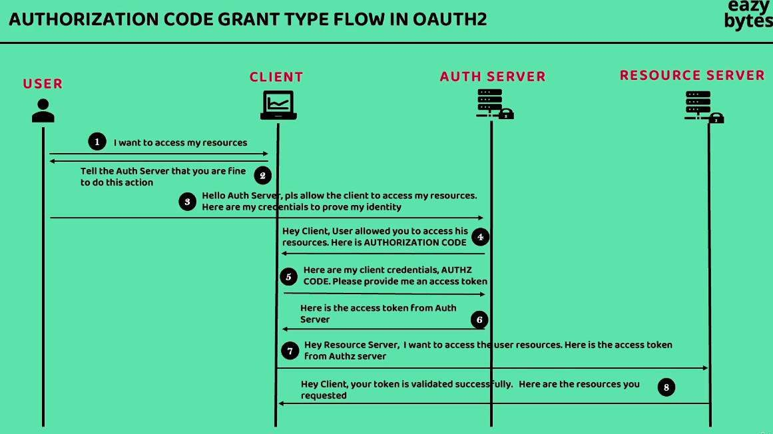Resource Server: gmail (username, profile)

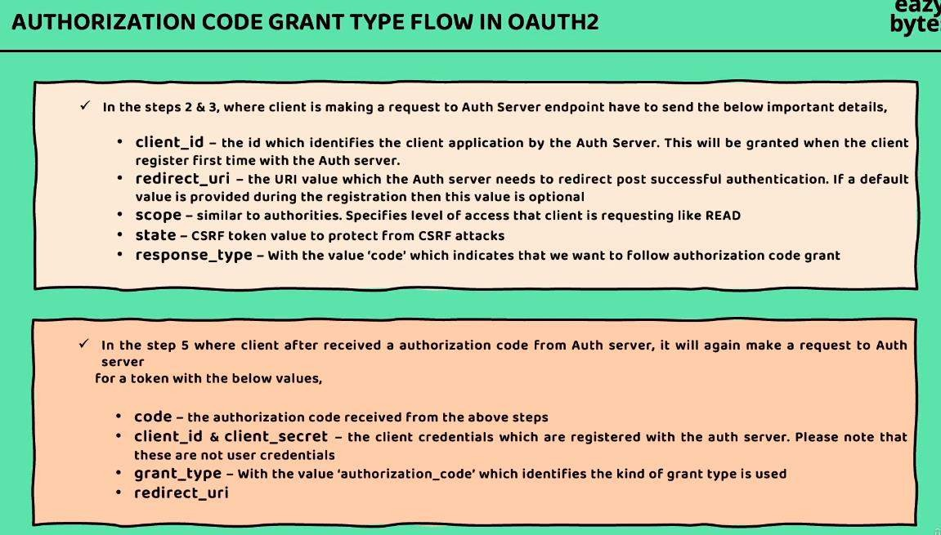

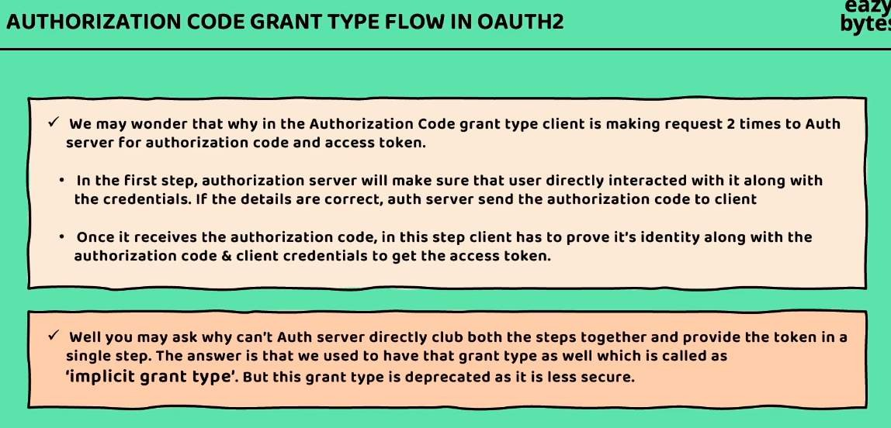

## Flow of the security in the microservice:

Authorization code grant type because the gateway server cal call the another service account, loans, cards etc.

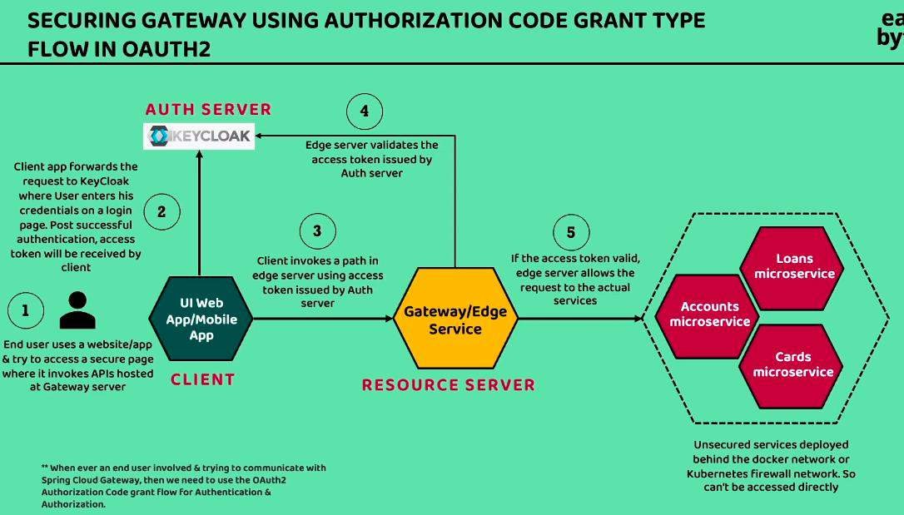

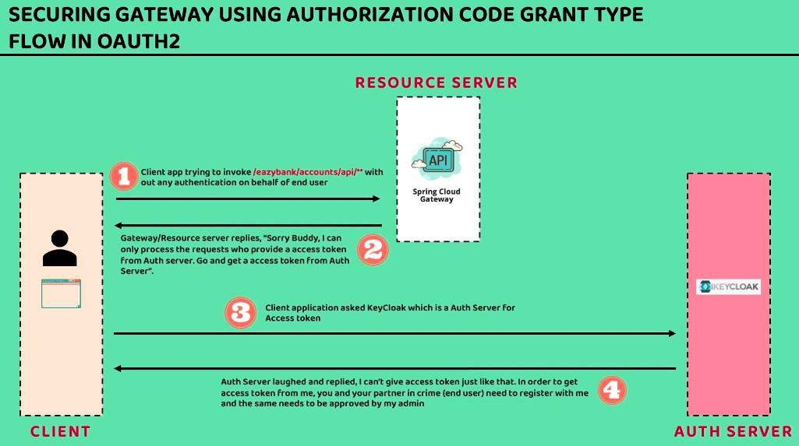

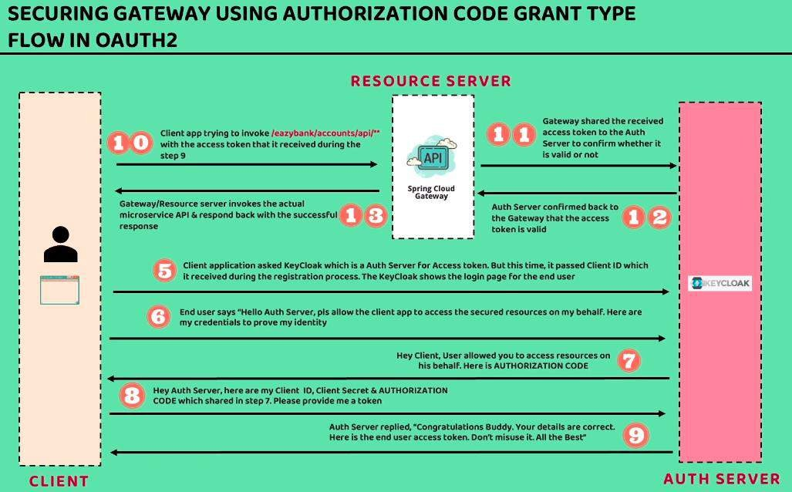

**Keyclock Rest API List**: <https://www.keycloak.org/docs-api/23.0.3/rest-api/index.html>

## We need to make the entity temporal coupling and event drivan mocroservice.

Ex: If one service is depende on the another service then we make the event so no one is go on hold for getting the output of the microservice. Every microservice is working in a thread.

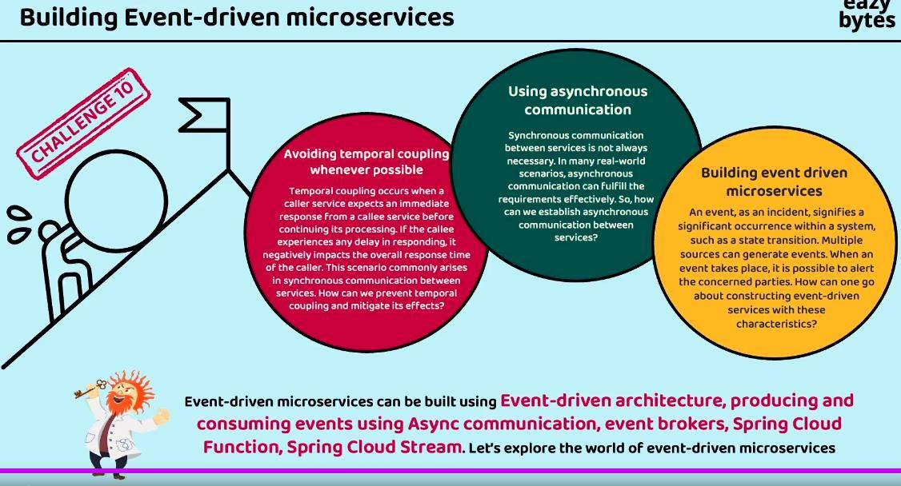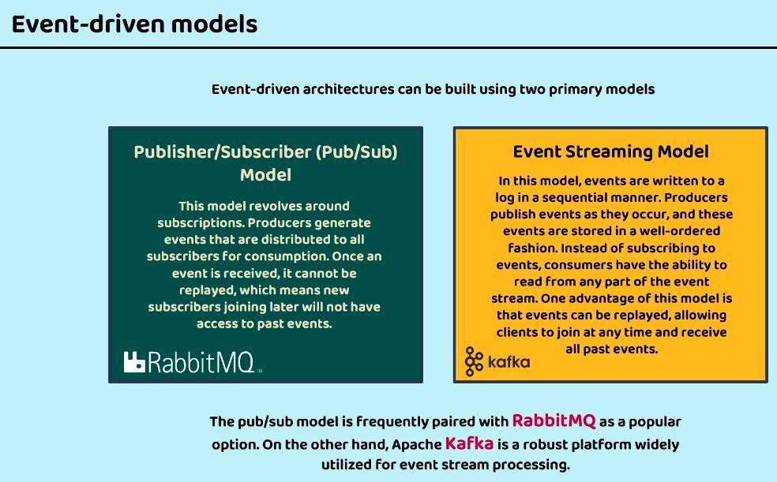

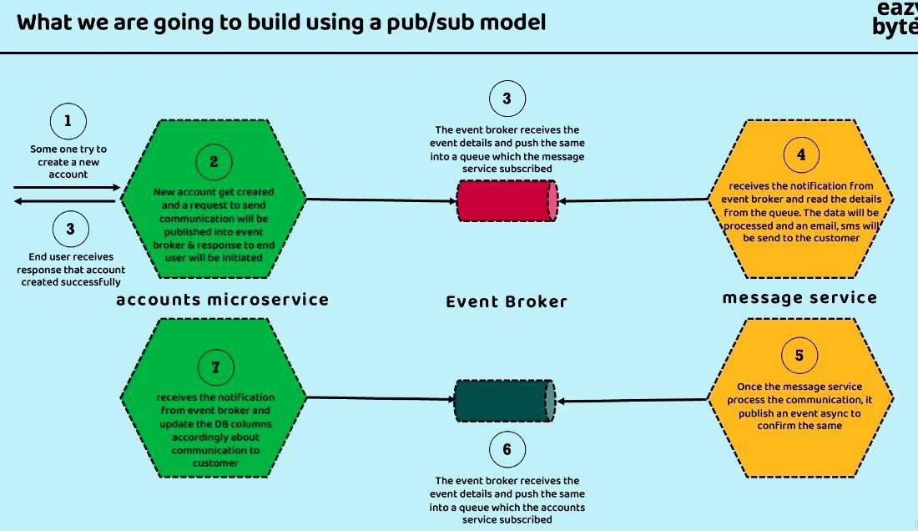

RabbitMQ for the PUB / SUB model:

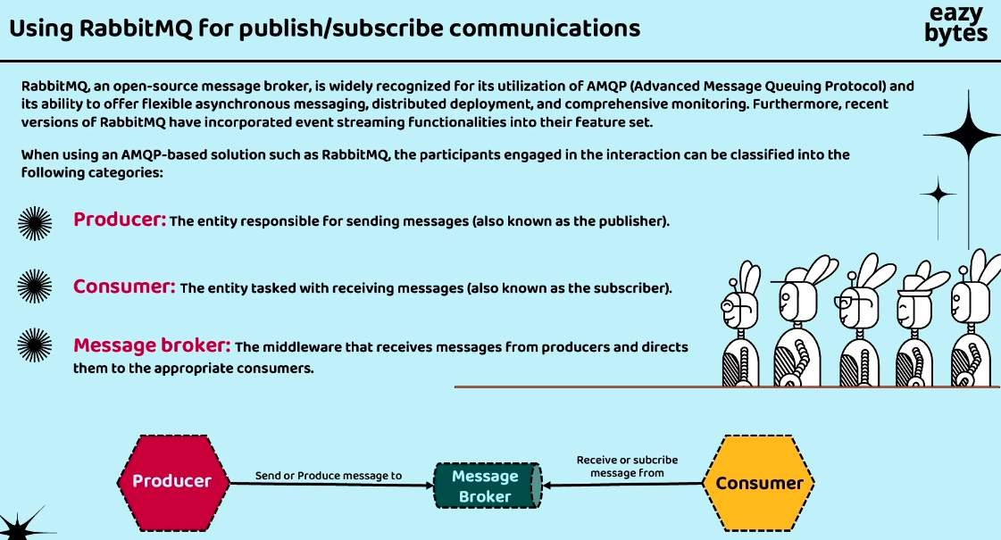

Message Broker is nothing but it is the rabbitMQ for the PUB / SUB Model. For Event steaming Model it is Apache Kafka.

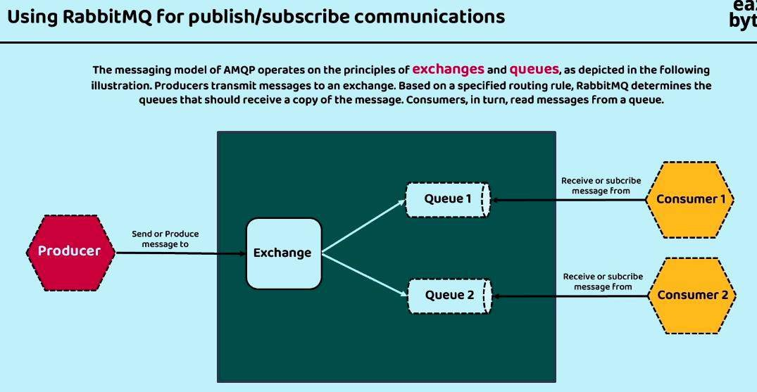

**Spring Cloud Function:** Function are implemente in the google so when ever we have require to change the coding language the we can do in directly from the cloud.

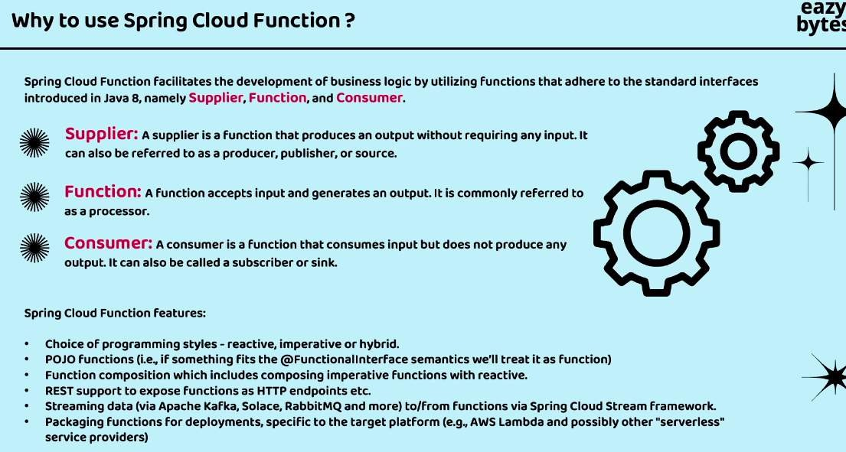

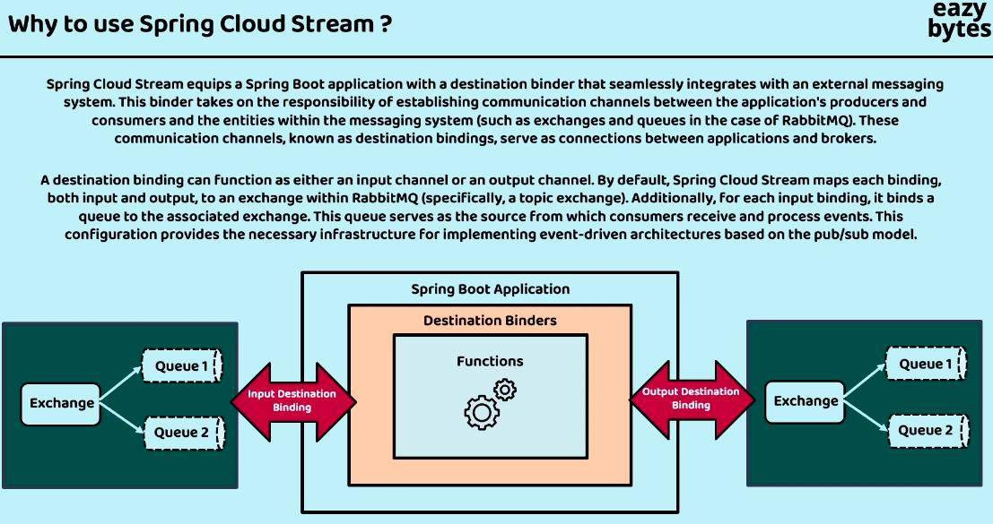

<https://spring.io/projects/spring-cloud-stream/>

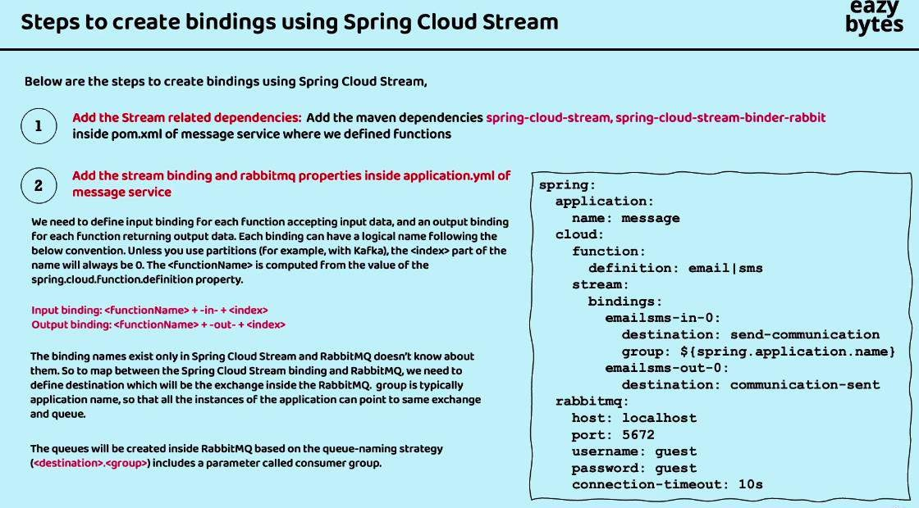

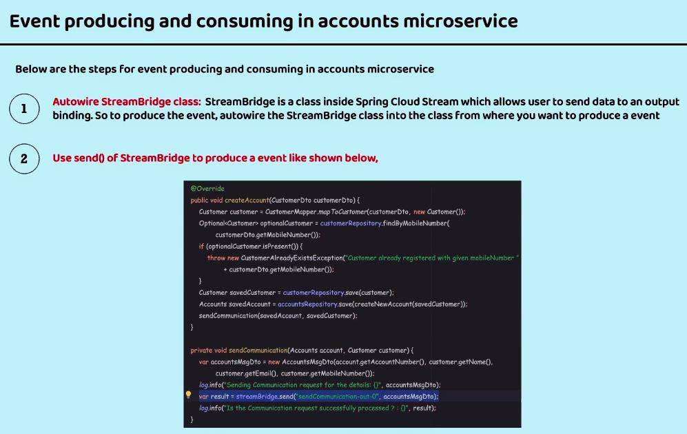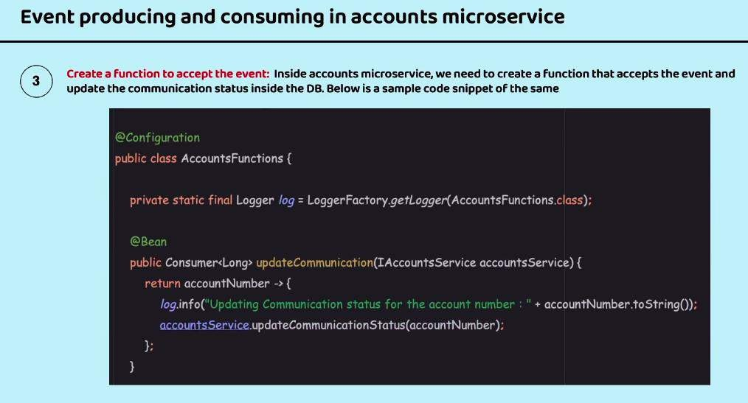

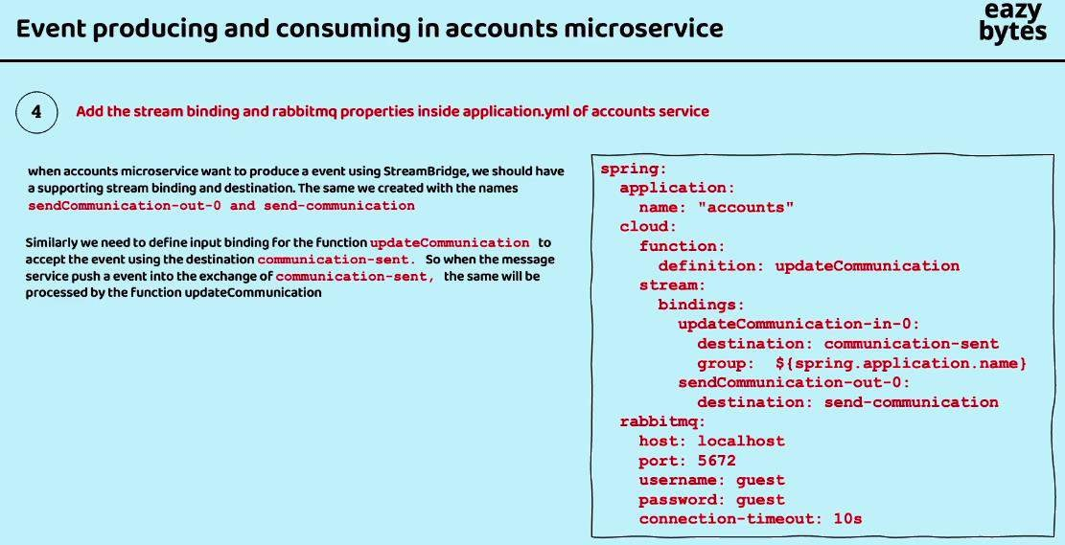

## Apache Kafaka Vs RabbitMQ

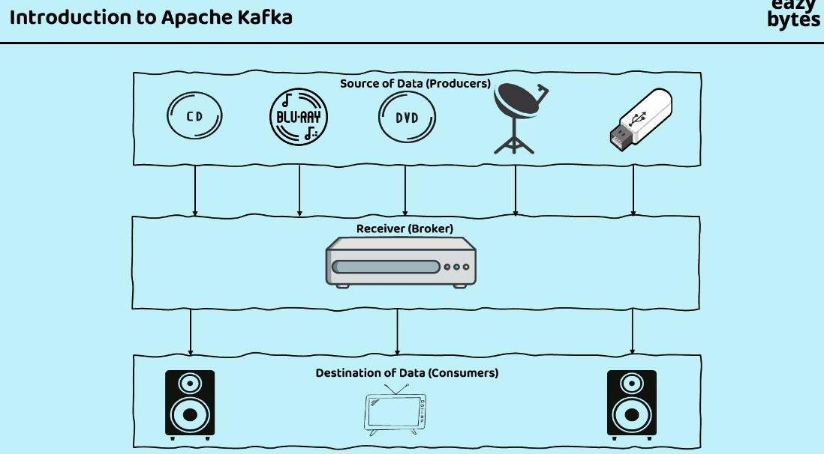

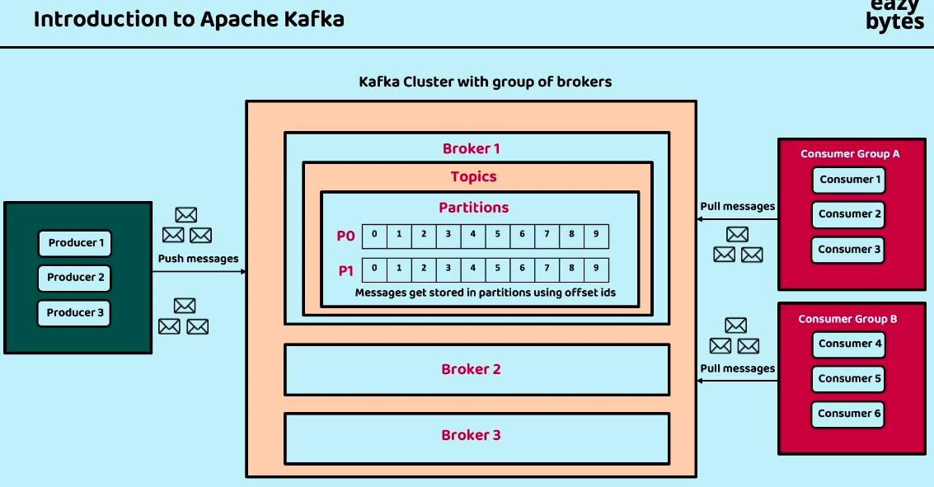

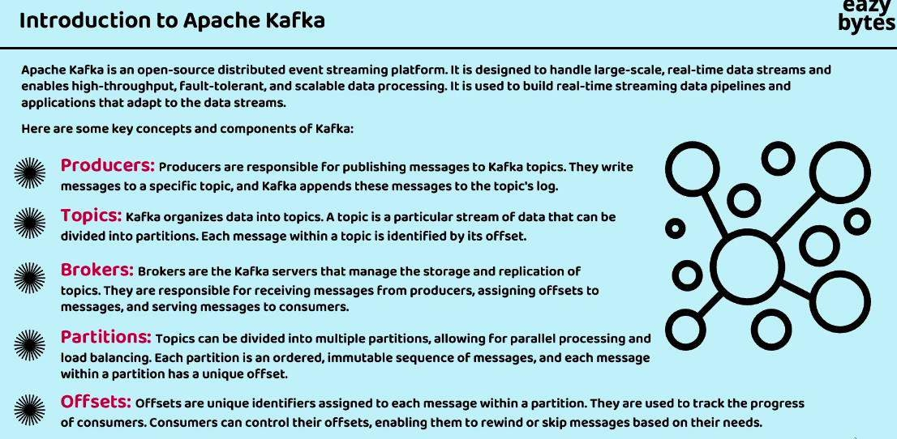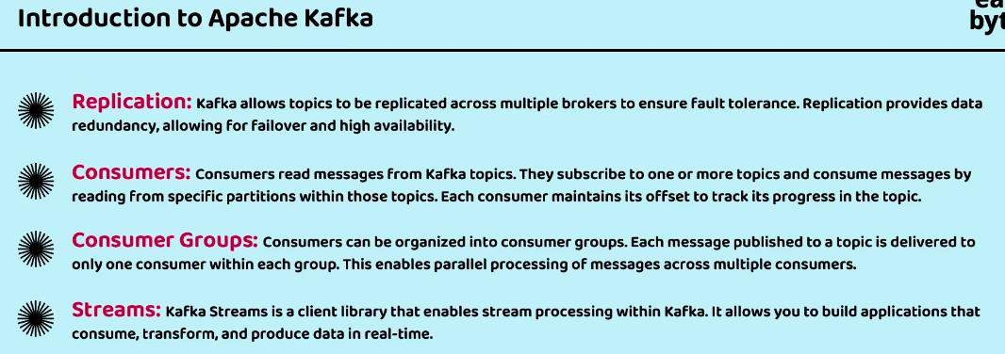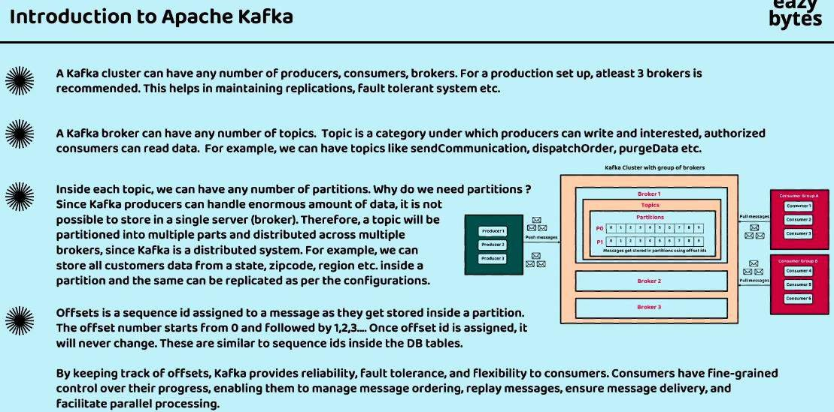

**Producer Flow:**

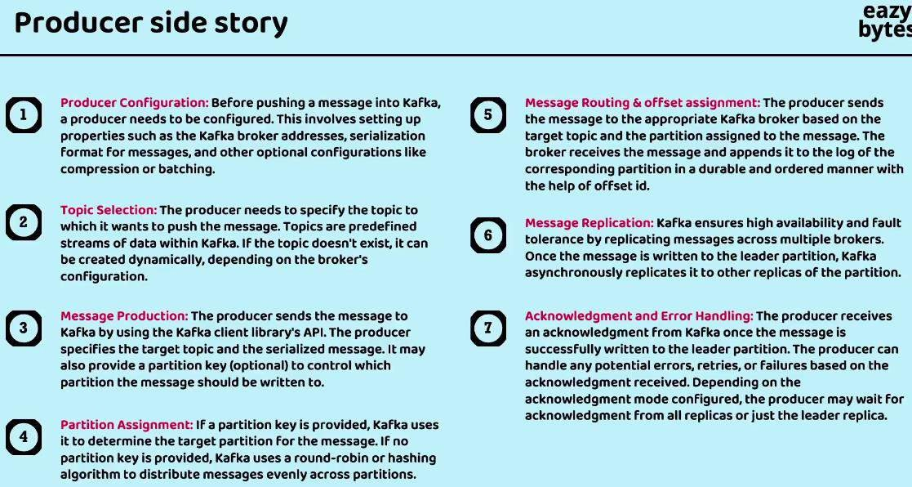

After all the above steps the message is stored in the message broker successfully.

## Consumer Flow:

Install the Apche Kafka in the local System: <https://kafka.apache.org/> Download steps: <https://kafka.apache.org/quickstart>

Kafka Start Command:

KAFKA_CLUSTER_ID="$(bin/kafka-storage.sh random-uuid)"

bin/kafka-storage.sh format -t $KAFKA_CLUSTER_ID -c config/kraft/server.properties bin/kafka-server-start.sh config/kraft/server.properties

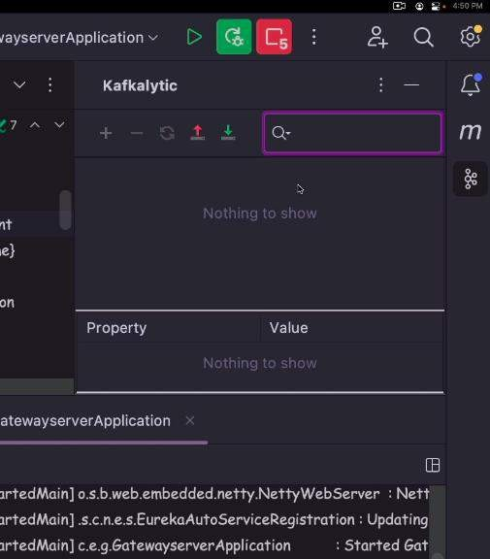Plugin for the Kafka in the Spring Boot IDE:

Copy the configuration from the bitnami <https://github.com/bitnami/containers/blob/main/bitnami/kafka/docker-compose.yml>

## Container Orchestration:

Ex: the Man who guide which one to play to which which are on the waiting state to play.



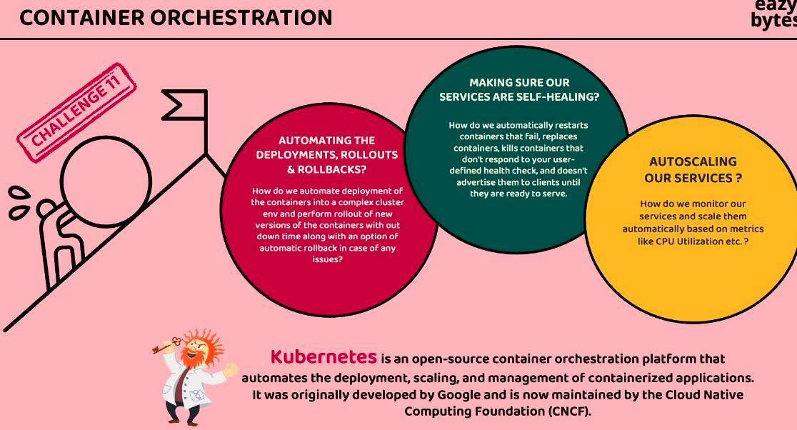

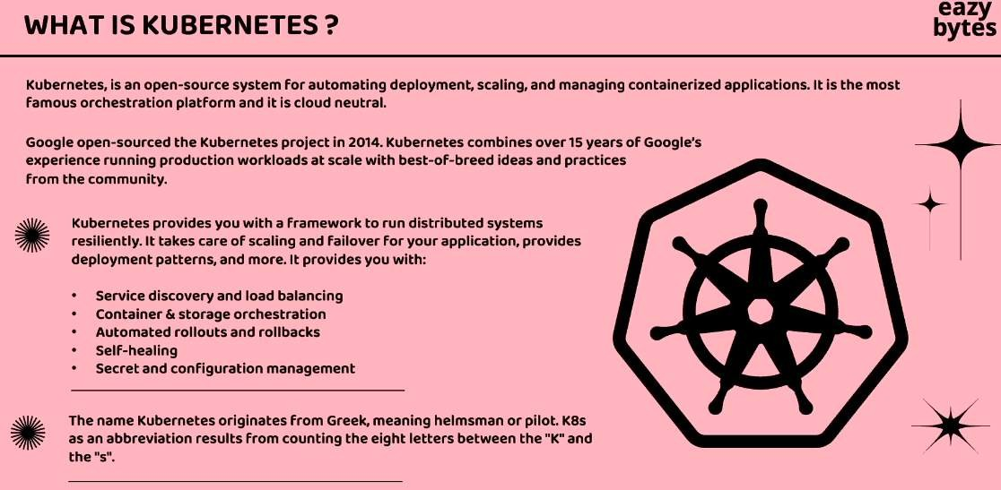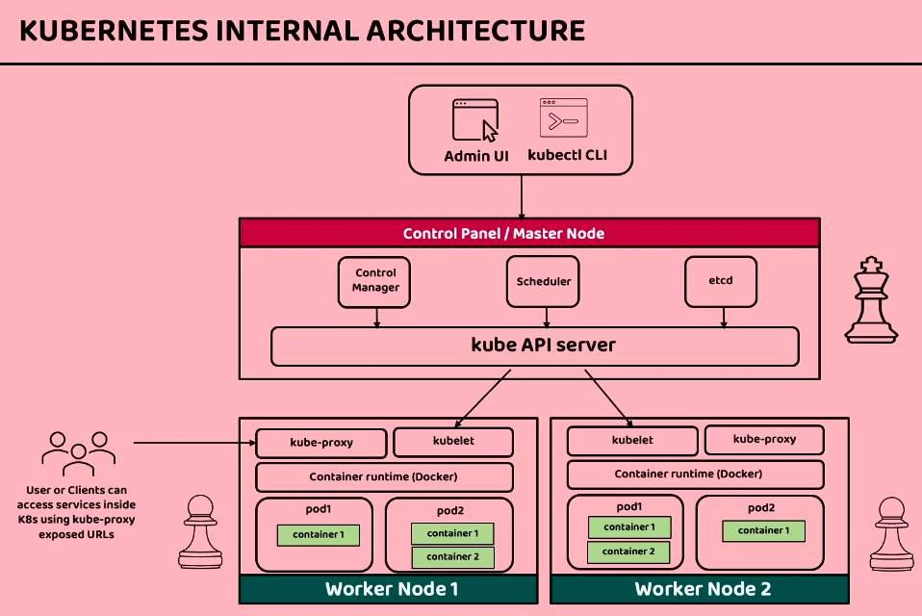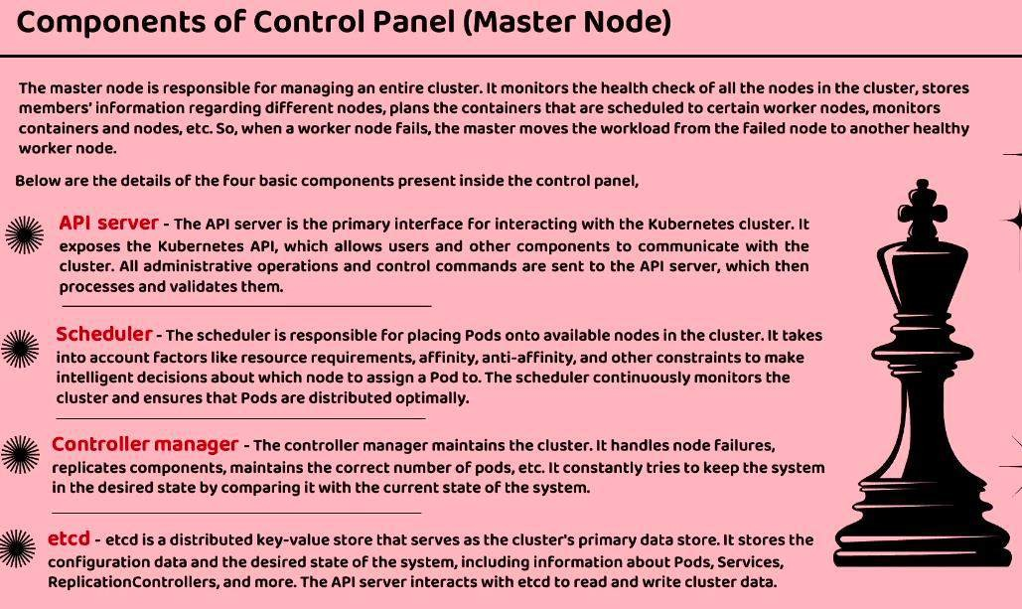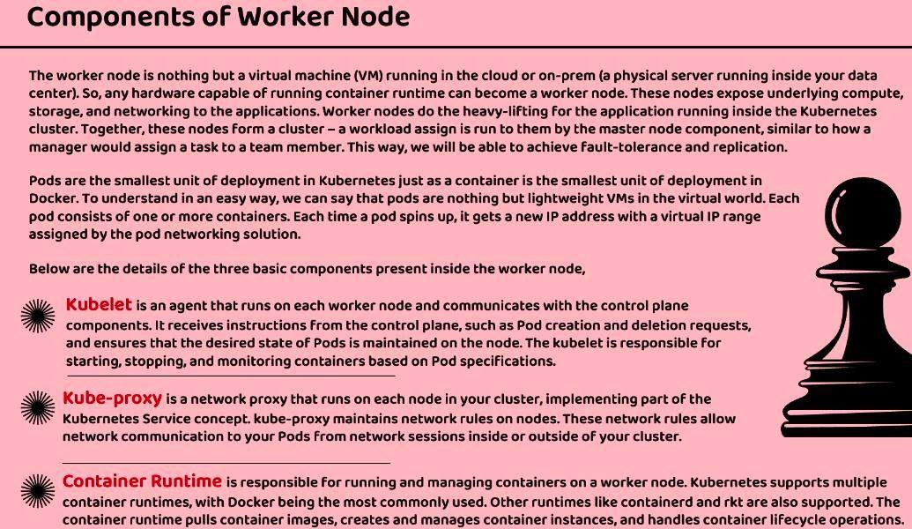

Install the Kubernetes in the local with the Docker Desktop [https://docs.docker.com/desktop/kubernetes/:](https://docs.docker.com/desktop/kubernetes/)

## Install the Kubectl in Local:

<https://kubernetes.io/docs/tasks/tools/install-kubectl-linux/>

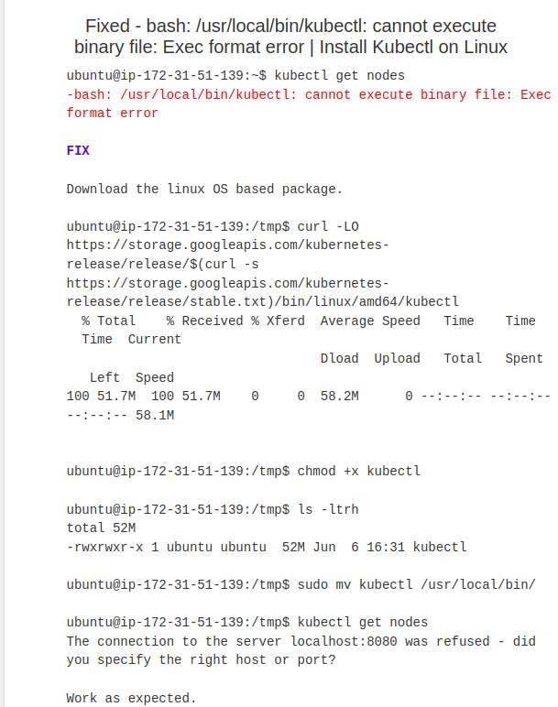

>> curl -LO https://storage.googleapis.com/kubernetes- release/release/$(curl -s [https://storage.googleapis.com/kubernetes-](https://storage.googleapis.com/kubernetes-release/release/stable.txt) [release/release/stable.txt](https://storage.googleapis.com/kubernetes-release/release/stable.txt))/bin/linux/amd64/kubectl

chmod +x kubectl

sudo mv kubectl /usr/local/bin/ kubectl get nodes

Instal the Kubectl in the System.

1. Check the File Type:

Confirm that the kubectl path you are trying to use is indeed a file. You can use the file command to check:

>> file /home/pritesh_desai/.local/bin/kubectl

1. Execute Directly:

If the file is indeed an executable, try running it directly:

>> /home/pritesh_desai/.local/bin/kubectl

1. Re-download kubectl:

Download a fresh copy of kubectl from the official Kubernetes releases page. Make sure to get the version that corresponds to your operating system and architecture.

>> sudo curl -LO https://storage.googleapis.com/kubernetes- release/release/$(curl -s https://storage.googleapis.com/kubernetes- release/release/stable.txt)/bin/linux/amd64/kubectl

>> sudo mv kubectl /home/pritesh_desai/.local/bin/

>> chmod +x /home/pritesh_desai/.local/bin/kubectl

1. Check PATH Variable:

Ensure that the directory /home/pritesh_desai/.local/bin/ is in your PATH variable. You can add it by modifying your shell configuration file (e.g., ~/.bashrc, ~/.zshrc, etc.):

>> export PATH="$PATH:/home/pritesh_desai/.local/bin/"

>> source ~/.bashrc

Install the Kubernetes dashboard

Install: <https://kubernetes.io/docs/tasks/access-application-cluster/web-ui-dashboard/>

http://localhost:8001/api/v1/namespaces/kubernetes-dashboard/services/https:kubernetes- dashboard:/proxy/

Get the token: [https://github.com/kubernetes/dashboard/blob/master/docs/user/access-](https://github.com/kubernetes/dashboard/blob/master/docs/user/access-control/creating-sample-user.md) [control/creating-sample-user.md](https://github.com/kubernetes/dashboard/blob/master/docs/user/access-control/creating-sample-user.md)

>> kubectl -n kubernetes-dashboard create token admin-user

>> kubectl get secret admin-user -n kubernetes-dashboard -o jsonpath={".data.token"} | base64

-d

Create the user

Then run the config file:

>> kubectl apply -f 2_configmaps.yaml

>> kubectl get deployments

>> kubectl get services

>> kubectl get replicaset

>> kubectl get pods

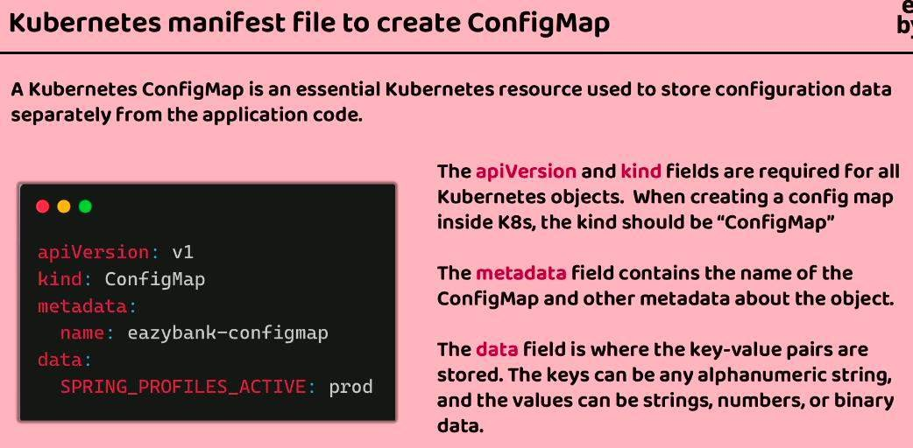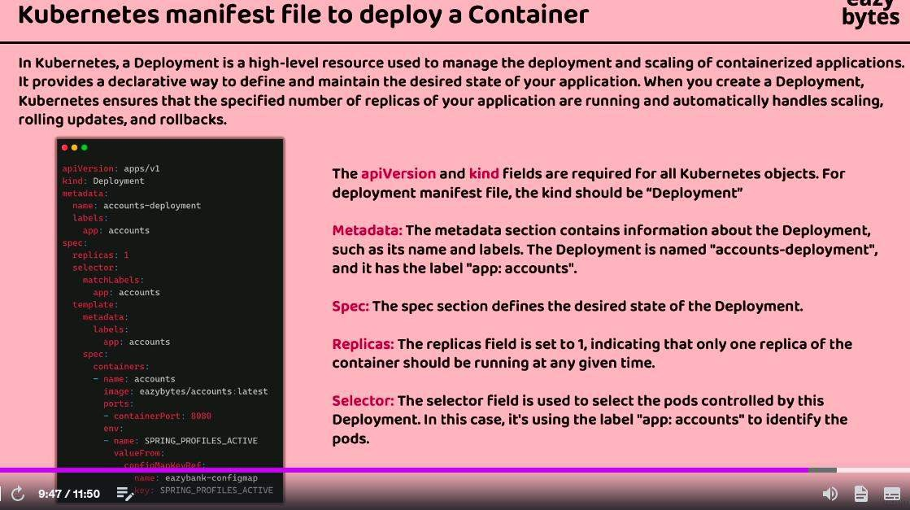For delete the configfile: kubectl delete -f 2_configmaps.yaml

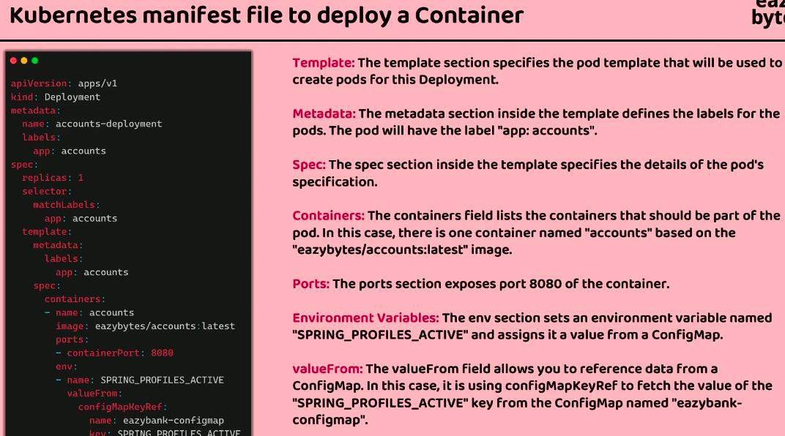

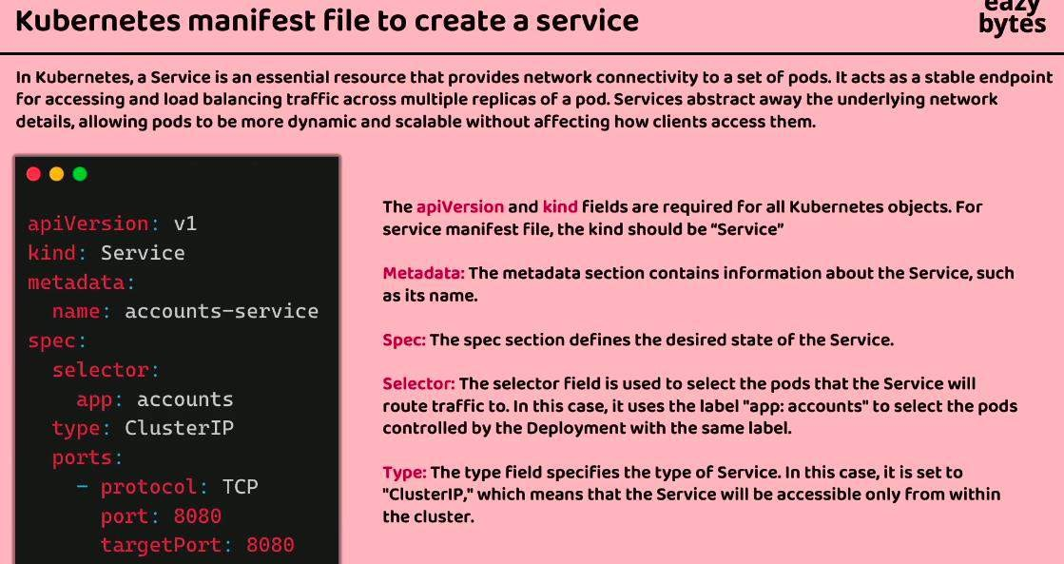

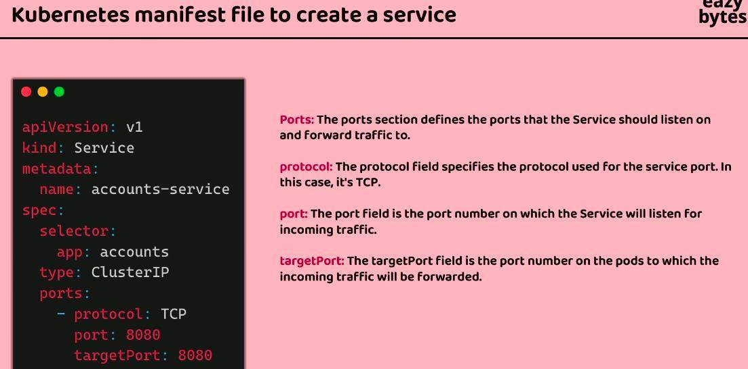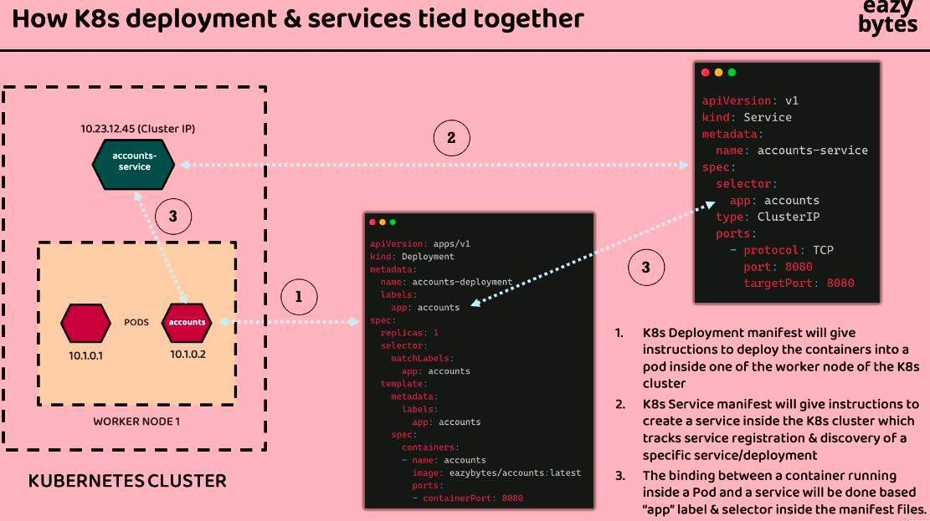

Get the Services in the k8:

>> kubectl get services Get the Details of the pods:

>> kubctl describe pods [gatewayserver-deployment-1234] [pod name]

Get all the Last event performed in the Kubectl using the below command:

>> kubectl get events --sort-by=.metadata.creationTimestamp

Change the number of replicas using the below command:

>> kubectl scale deployment accounts-deployment --replicas=1

Upload new changes in kubernetees without any down type:

Ex: we need to change the image from s13 to s12.

>> kubectl set image deployment gatewayserver-deployment gatewayserver=priteshdesai1811/gatewayserver:s12 - -record

Rollback the changes that made at last:

>> kubectl rollout history deployment gatewayserver-deployment (check history of commits)

>> kubectl rollout undo deployment gatewayserver-deployment - -to-revision=1

Deployment >> replicaset >> pods >> Container

## Different Service types in the Kubernetees

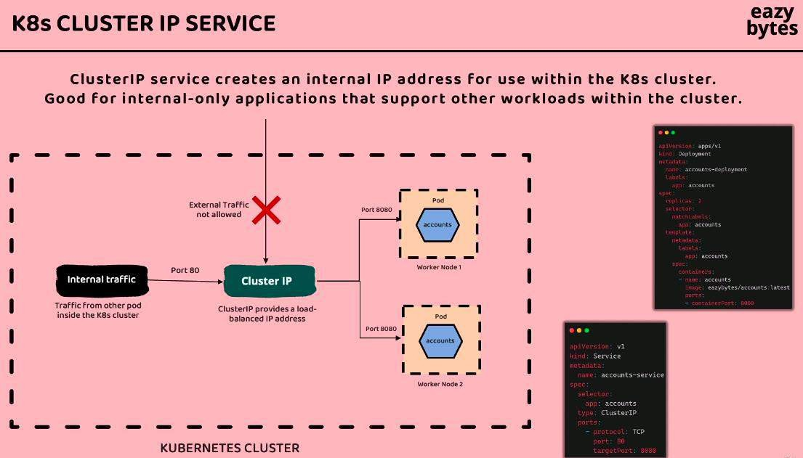

With using the ClusterIP service: we have define the ipaddress for accessing the pods of the workernodes. No other can access without the define Ip address. Above 80 is the define if in property file.

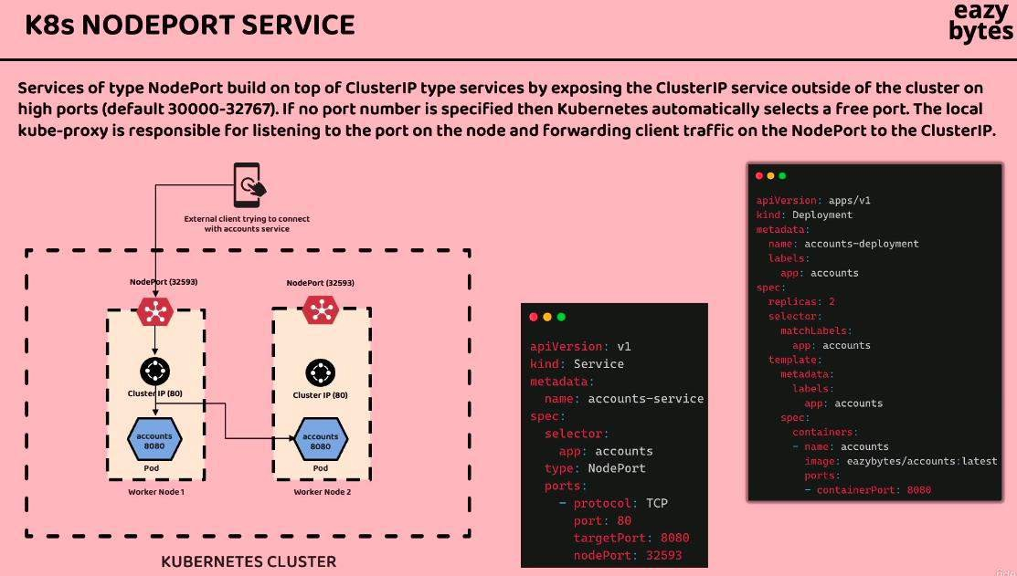

In that we define the nodeport and from the node port it goes to cluster node.

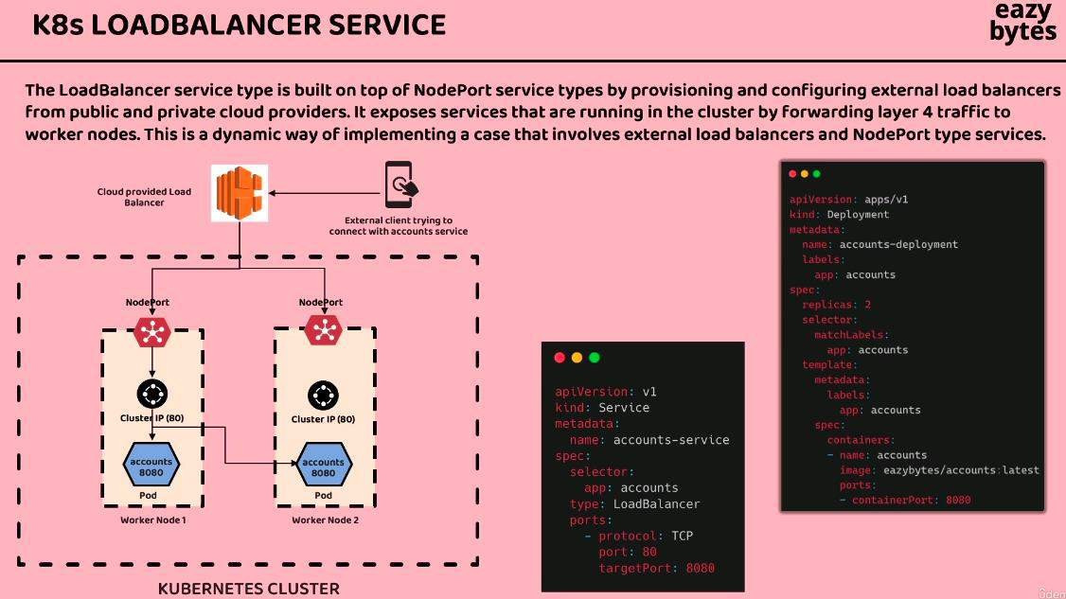

In that we have the load balancer above all the nodeport and cluster ip. Load balancer have the public ip to expose. It is not change till we can change it.

We have one problem in the deploy with the above kubenetes hole approach: we need to manually add the change and remove changes. If we have 1000 of microservice with the different environment then that approach does not work.

For Automatated the process we have introduce the **Helm**.

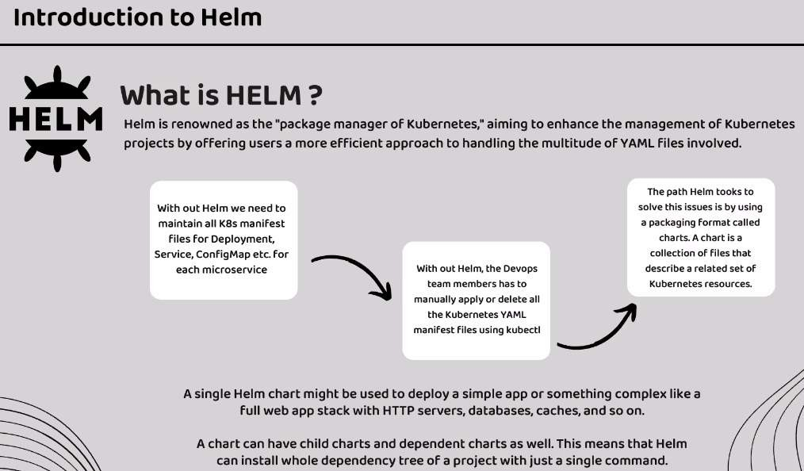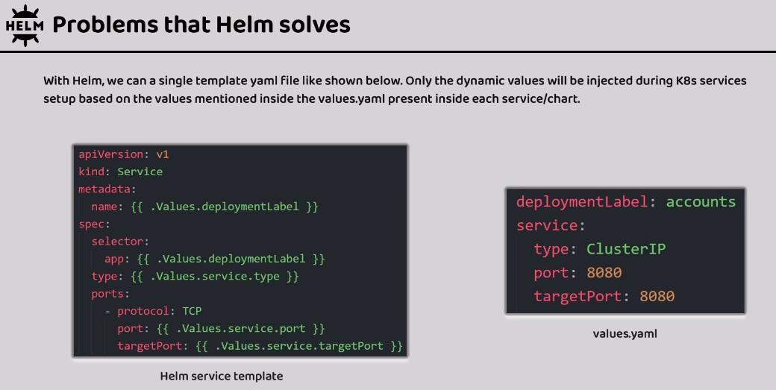

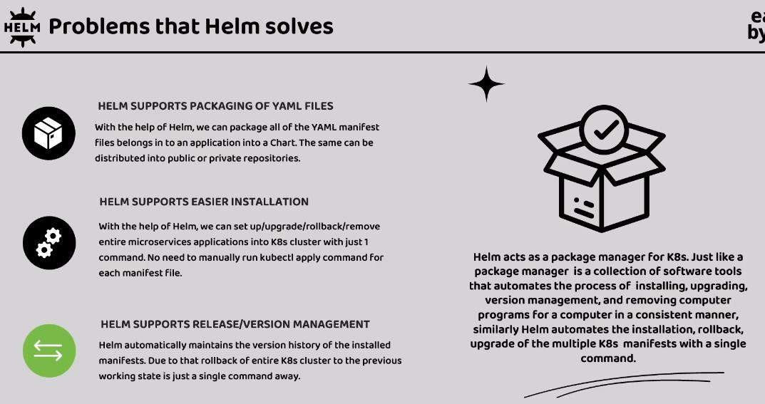

Install the Helm in the local:

<https://helm.sh/docs/intro/install/> : Install using the package Manager.

Install the Bitnami Helm Chart: <https://docs.bitnami.com/kubernetes/infrastructure/kubeapps/get-started/install/>

>> helm repo add bitnami <https://charts.bitnami.com/bitnami>

To check all the environment in the Heml

>> helm env Uninstall >> helm uninstall [happy-panda] = [] name of the image

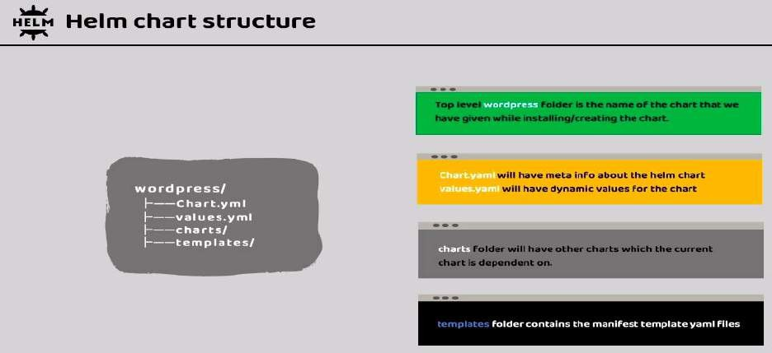

Helm Create:

Helm create [eazybank-common]: [] = name of the the Helm we need to create.

For compile the helm configuration for the dependant services:

>> helm dependencies build

Get the deployment information:

>> helm template .

Bitnami Helm Chart: <https://github.com/bitnami/charts>

# INSTALL KEYCLOCK CHART:

Copy the keyclock folder from the above git and change the below in the values.yaml

>> change service.type with LoadBalancer in place of clusterIP. Change because we have to change the user and role details in the keyclock.

>> change the auth.adminPassword with the value “Password”

Then fist build the keyclock inside the keyclock folder.

>> helm dependencies build

After build we need to install the keyclock form the keyclock folder.

>> helm install keycloak keycloak/

Remove the default apache page from the ubuntu

>> cd var/www/html/

>> mv index.html index_1.html

>> sudo service apache2 restart

>> ps aux | grep apache

>> sudo killall apache2

Delete the Persistance Volume Claim form the Kubenatees UI dashboard or command to reinstall the image.

>> kubectl get pvc

>> kubectl delete pvc [pvcname]

# INSTALL KAFKA CHART:

in values.yaml changes:

* Change the replicaCount as 1 because we don’t want more replica to test in the local.
* Change PLAINTEXT inplace of “SASL_PLAINTEXT”

Then fist build the keyclock inside the keyclock folder.

>> helm dependencies build

After build we need to install the keyclock form the keyclock folder.

>> helm install kafka kafka/

# INSTALL KUBE-PROMETHEUS CHART:

in values.yaml changes: additionalScrapConfig.enabled: change false to true.

additionalScrapConfig.type: change the internal from the external additionalScrapConfig.internl.jobList: change

[

{

"job_name": "configserver", "metrics_path": "/actuator/prometheus", "static_configs": [

{

"targets": ["configserver:8071"]

}

]

},

{

"job_name": "eurekaserver", "metrics_path": "/actuator/prometheus", "static_configs": [

{

"targets": ["eurekaserver:8070"]

}

]

},

{

"job_name": "accounts", "metrics_path": "/actuator/prometheus", "static_configs": [

{

"targets": ["accounts:8080"]

}

]

},

{

"job_name": "loans",

"metrics_path": "/actuator/prometheus", "static_configs": [

{

"targets": ["loans:8090"]

}

]

},

{

"job_name": "cards",

"metrics_path": "/actuator/prometheus", "static_configs": [

{

"targets": ["cards:9000"]

}

]

},

{

"job_name": "gatewayserver", "metrics_path": "/actuator/prometheus", "static_configs": [

{

"targets": ["gatewayserver:8072"]

}

]

}

]

from the [].

Then fist build the keyclock inside the keyclock folder.

>> helm dependencies build

After build we need to install the keyclock form the keyclock folder.

>> helm install prometheus kube-prometheus/

# INSTALL GRAFANA-LOKI CHART:

No change in value.yaml

Then fist build the keyclock inside the keyclock folder.

>> helm dependencies build

After build we need to install the keyclock form the keyclock folder.

>> helm install loki grafana-loki/

# INSTALL GRAFANA-TEMPO CHART:

in values.yaml changes: Open telemetry (otlp) otlp.http: true

otlp.grpc: true

Then fist build the keyclock inside the tempo folder.

>> helm dependencies build

After build we need to install the keyclock form the keyclock folder.

>> helm install tempo grafana-tempo/

## INSTALL GRAFANA CHART: add the datasource details of the prometheus, loki, tempo.

**>> kubectl get services: to check all the services og the garafana and all.**

in values.yaml changes:

datasource:

secretDefinition:

apiVersion: 1

deleteDatasources:

* name: Prometheus
* name: Loki
* name: Tempo

datasources:

* name: Prometheus type: prometheus uid: prometheus

url: http://prometheus-kube-prometheus-prometheus:9090 access: proxy

orgId: 1 basicAuth: false isDefault: false version: 1 editable: true jsonData:

httpMethod: GET

* name: Tempo type: tempo uid: tempo

url: http://tempo-grafana-tempo-query-frontend:3200 access: proxy

orgId: 1 basicAuth: false isDefault: false version: 1 editable: true jsonData: httpMethod: GET

serviceMap:

datasourceUid: 'prometheus'

* name: Loki type: loki uid: loki

access: proxy orgId: 1 editable: true

url: http://loki-grafana-loki-gateway:80 jsonData:

httpHeaderName1: "X-Scope-OrgID" derivedFields:

- datasourceUid: tempo matcherRegex: "\\[.+,(.+),.+\\]" name: TraceID

url: '$${ value.raw}' secureJsonData:

httpHeaderValue1: "tenant1"

**For Deploy the complete Application with the environment:**

>> cd enviroments/

>> helm install priteshdesai1811 prod-env/

>> helm install [release_name] [enviroment_config_folder_name]

To check the services is running or not goto the kubernetes UI dashboard and go to the services, Pods

**Updates the value** in the any service and deploy that using the helm:

>> go to cd enviroments/prod-env

>> helm dependencies build

>> cd ../enviroments/

>> helm upgrade eazybank prod-env\

## Rollback the change

>> helm history eazybank

>> helm rollback eazybank 1 // [1= revision number]

## Uninstall the change:

>> helm ls

>> helm uninstall easybank

**Alternate of the Helm is Kustomize.**

**Website: Kustomize.io All Commands:**

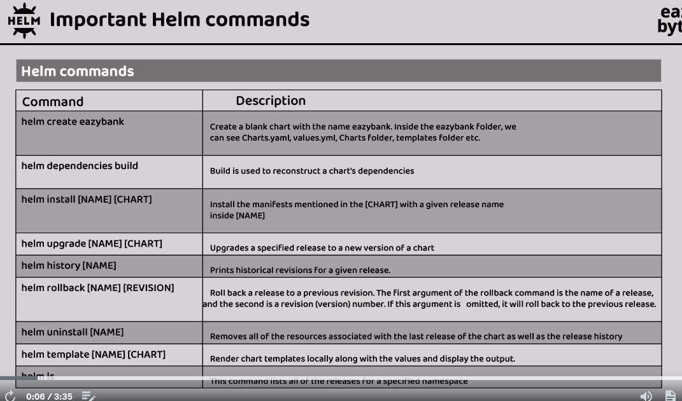

**Load Balancing:**

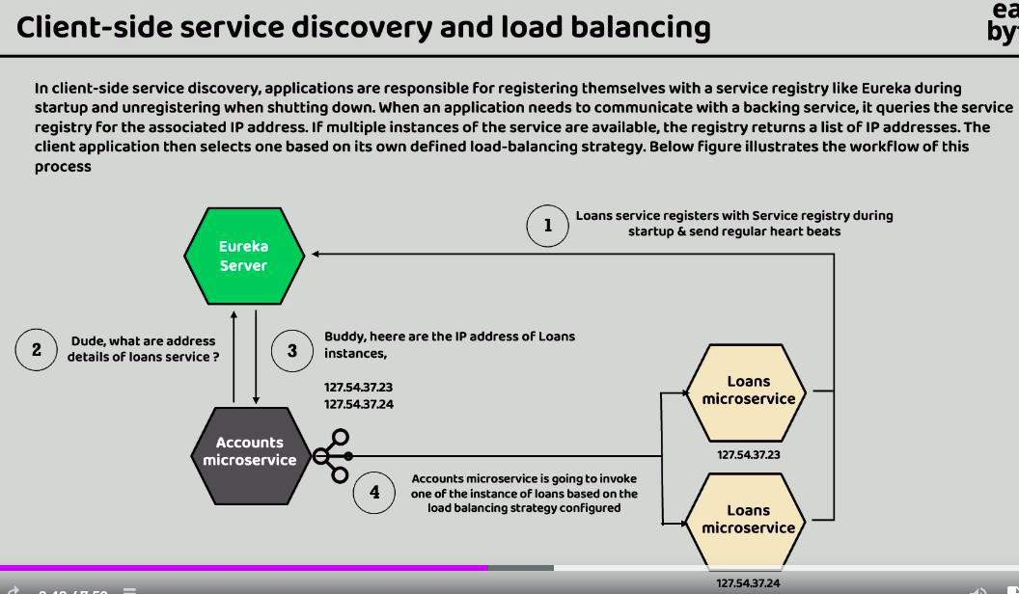**Client side Service Discovery:** using the Eureka server api registory

**Server side Discovery:** It is possible if we have deploy the services in the kubenetees clustering service. There is the K8s discovery server where all the api are registered so we don’t need to go in to the Eureka discovery for getting the mapping

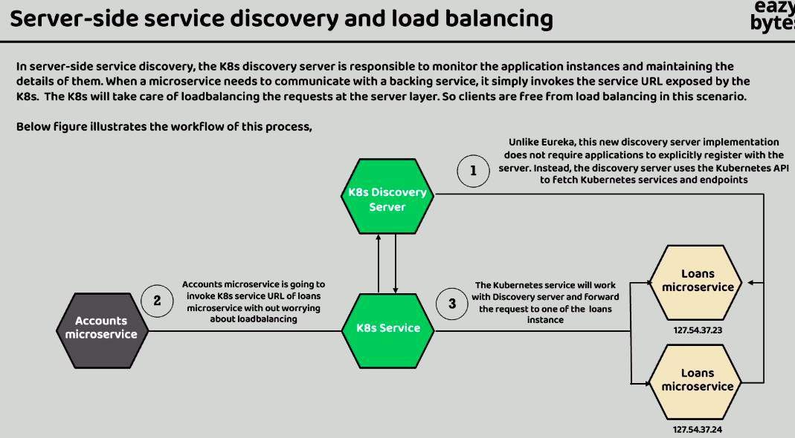

## Setup the Discovery Server at the Kubernetees at the server side we use the spring cloud kubernetes:

<https://spring.io/projects/spring-cloud-kubernetes/>

Blog for setup the k8s discovery server [https://spring.io/blog/2021/10/26/new-features-for-](https://spring.io/blog/2021/10/26/new-features-for-spring-cloud-kubernetes-in-spring-cloud-2021-0-0-m3/) [spring-cloud-kubernetes-in-spring-cloud-2021-0-0-m3/](https://spring.io/blog/2021/10/26/new-features-for-spring-cloud-kubernetes-in-spring-cloud-2021-0-0-m3/)

Change related to the Server side K8s Discovery service:

1. Accounts:
   1. Change the pom.xml for the eureka server related dependencies.
   2. Change in the Main spring boot application file annotation @EnableEurekaClient
   3. Change in the application.yml to remove the eureka server properties and add the k8 properties
   4. Go to the Feign client Implemetations and change below. Add url with the respective port number.

CardsFeignClient.java:

@FeignClient(name="cards", url = "http://cards:9000", fallback = CardsFallback.class)

LoansFeignClient.java:

@FeignClient(name="loans", url = "http://loans:8090",fallback = LoansFallback.class)

1. Cards:
   1. Change the pom.xml
   2. Change the Main file of the Spring boot. @EnableEurekaClient
   3. Change the application.yaml
2. Loans:
   1. Change the pom.xml
   2. Change the Main file of the Spring boot. @EnableEurekaClient
   3. Change the application.yaml
3. Gateway Server
   1. Chage pom.xml
   2. Change the Main file of the Spring boot. @EnableEurekaClient. With the url configuration.
   3. Change in application.yaml
4. Config changes in the yaml files of the environments and common services of the deployments:

[https://www.udemy.com/course/master-microservices-with-spring-docker-](https://www.udemy.com/course/master-microservices-with-spring-docker-kubernetes/learn/lecture/39947976#overview) [kubernetes/learn/lecture/39947976#overview](https://www.udemy.com/course/master-microservices-with-spring-docker-kubernetes/learn/lecture/39947976#overview)

## Cloud Providers for the K8 services:

We user the GCP: Google Cloud platform to achieve GKE(Google Kubenetess Engine).

GKE provide the free access for the cluster creation in the GCP. AWS and Azure have some changes for creating the Kubernetees services.

<https://cloud.google.com/free?hl=en>

Click on the console button above.

Install the Google Cloud CLI: <https://cloud.google.com/sdk/docs/install>

## Kubernetes Ingress:

ExternalName: use when we need to map the DNS name to the IP address. <https://kubernetes.io/docs/concepts/services-networking/service/#externalname>

Ingress is used to expose the Microservices out side the Network. <https://kubernetes.io/docs/concepts/services-networking/ingress/>

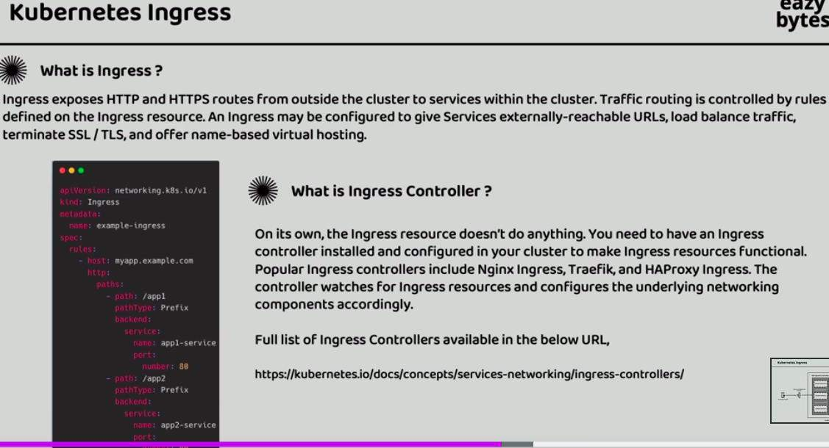

Ingress famous Controllers: Nginx Ingress, Traefik proxy, HAProxy ingress

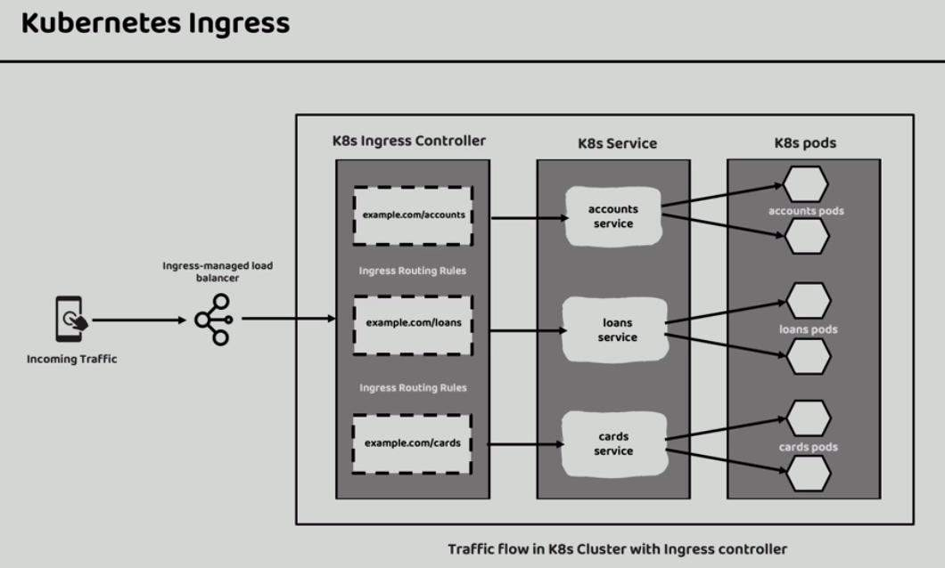

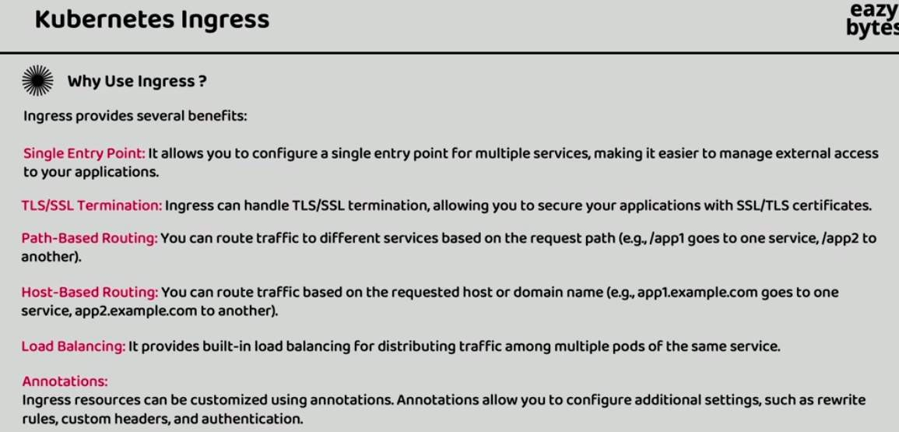

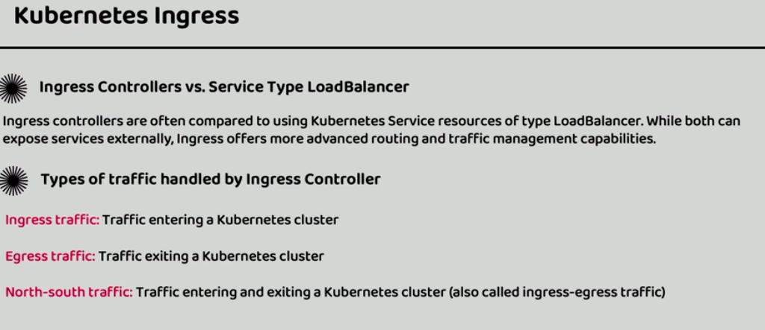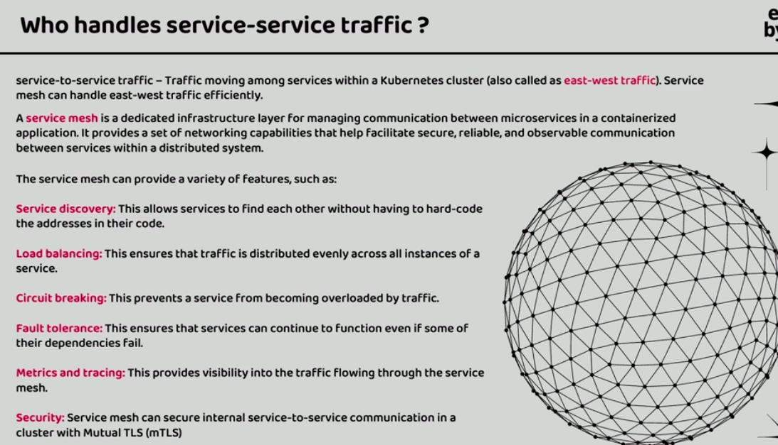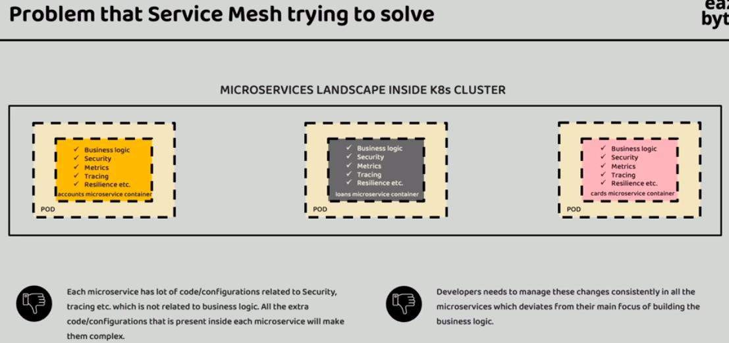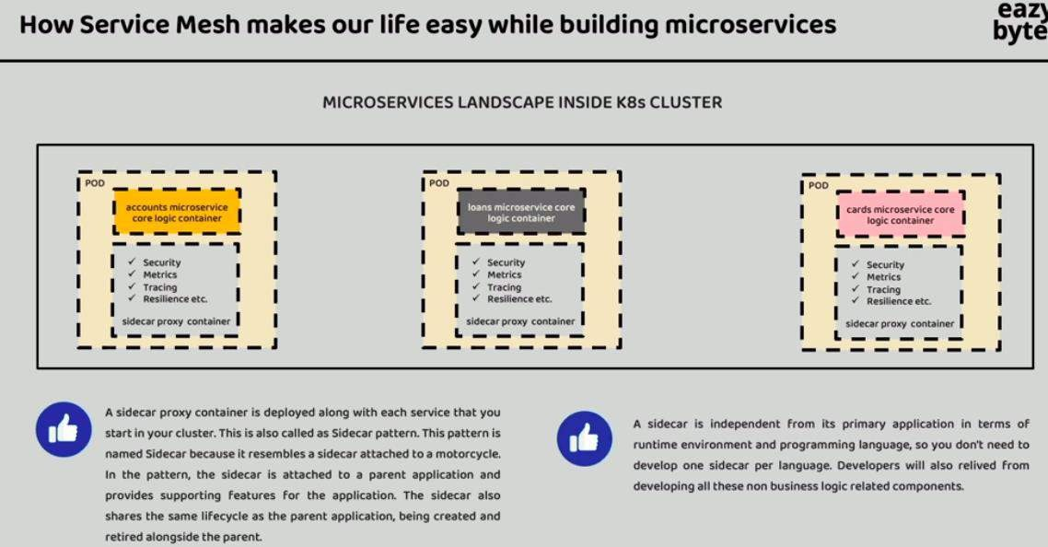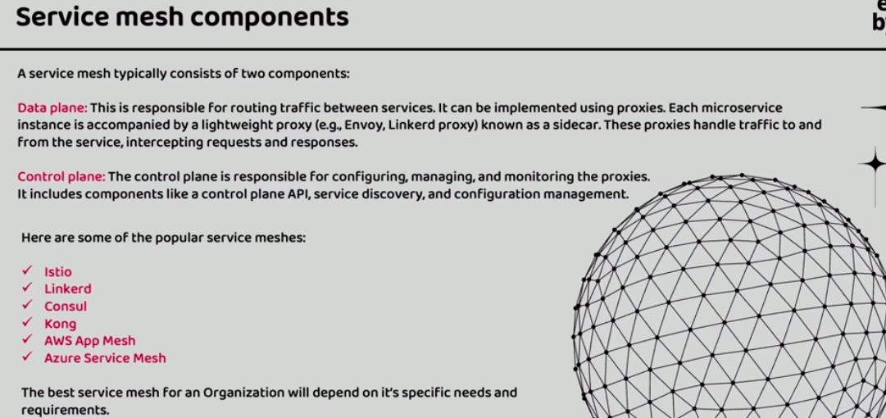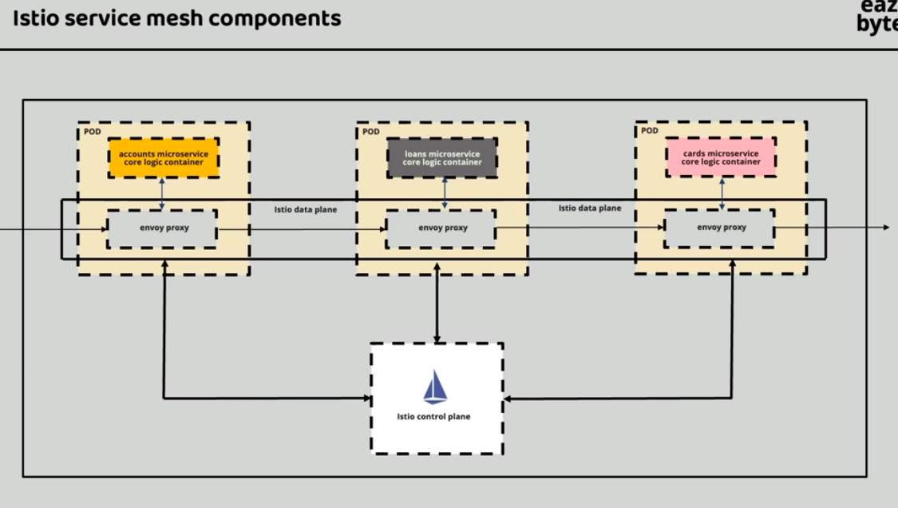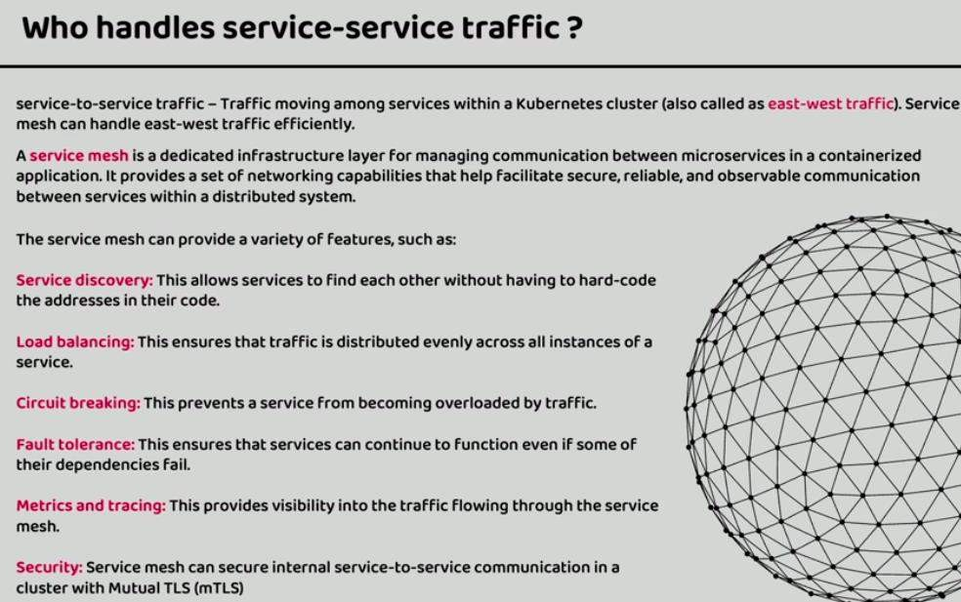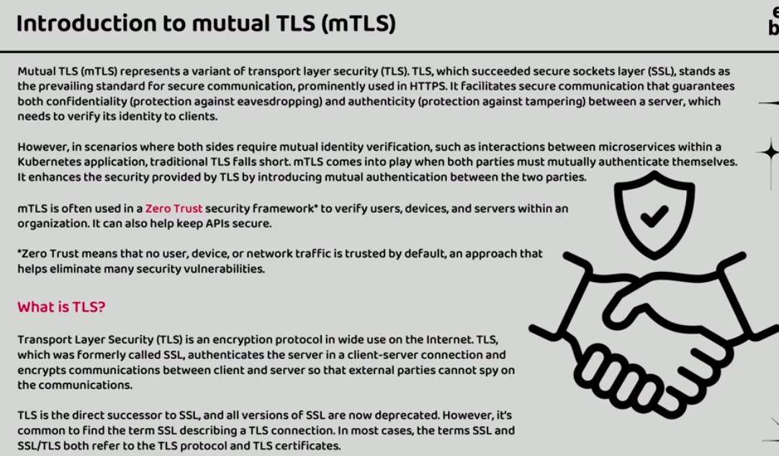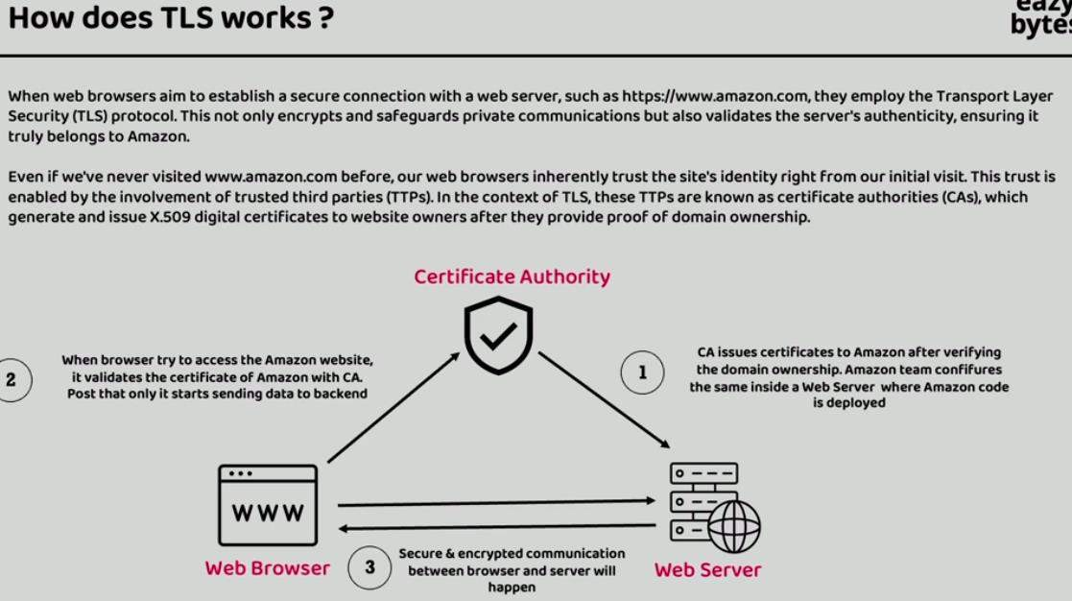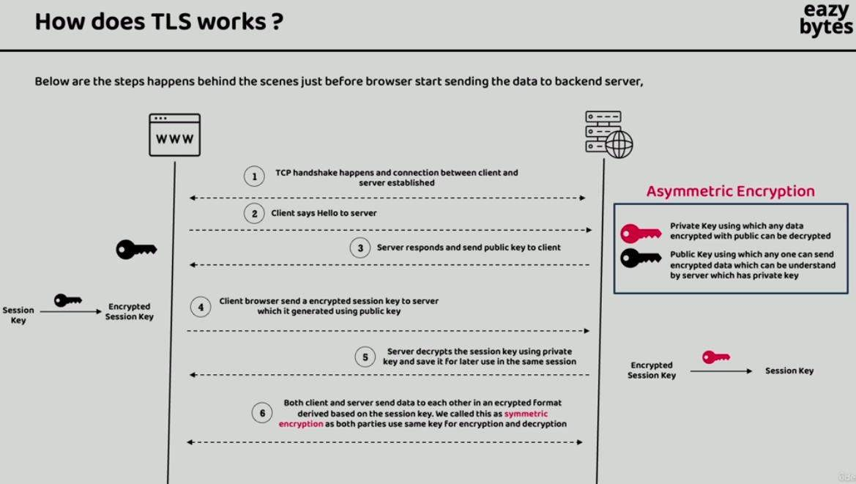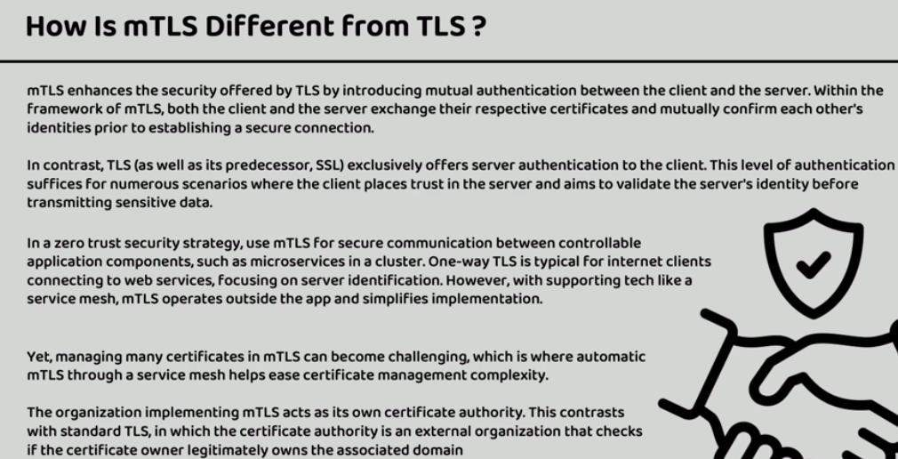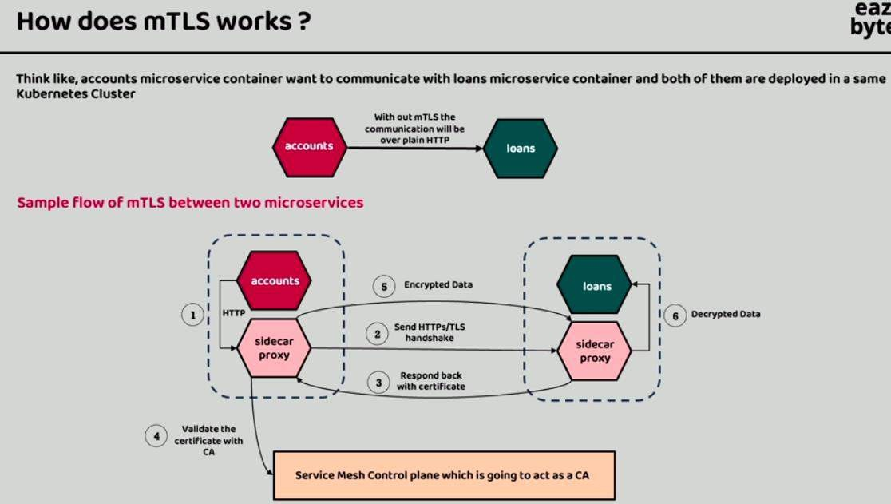

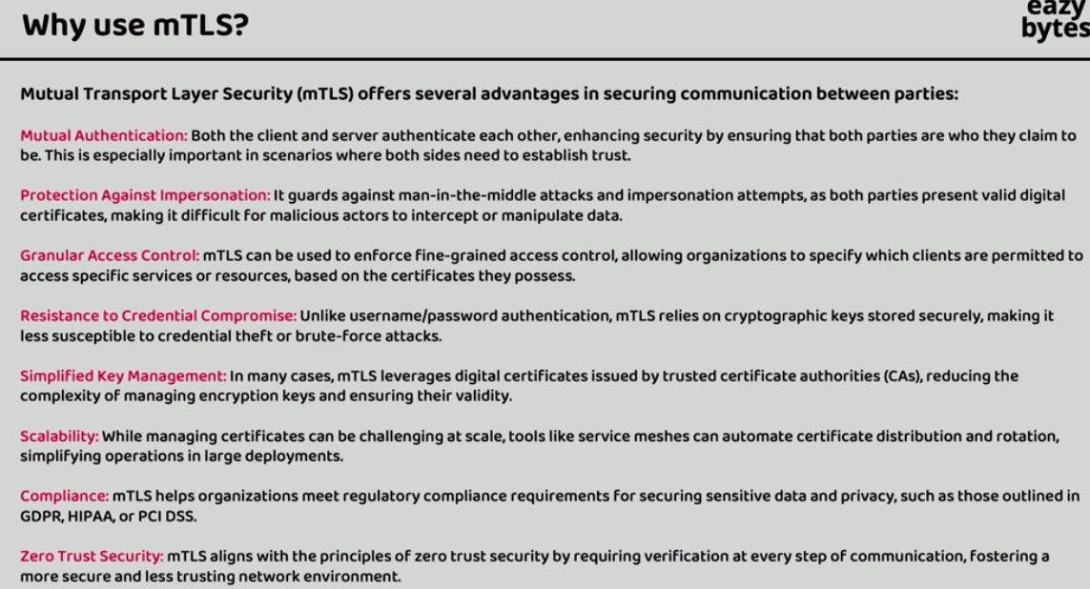

# USEFULL ENDPOINTS:

Eureka Server: http://localhost:8070/

Eureka Server Profile Config: http://localhost:8071/eurekaServer/dev Eureka Server Health Check: http://localhost:8071/actuator/health Eureka Server Instnces: http://localhost:8070/eureka/apps

Actuator Routes: http://localhost:8072/actuator/gateway/routes Actuator CircuitBreaker: http://localhost:8072/actuator/circuitBreakers